NAGARAJA H T | PAVAN S

   PENTAGON SPACE PVT. LTD. www.pentagonspace.in

**REACT JS NOTES**



**REACT JS**

React JS is a **declarative**, **efficient**, and flexible **JavaScript library** for building reusable UI components. It is an open-source, component-based front end library which is responsible only for the view layer of the application. It was initially developed and maintained by Facebook.

Why we use React JS?

The main objective of React JS is to develop User Interfaces (UI) that improves the speed of the apps. It uses virtual DOM (JavaScript object), which improves the performance of the app. The JavaScript virtual DOM is faster than the regular DOM. We can use React JS on the client and server-side as well as with other frameworks. It uses component and data patterns that improve readability and helps to maintain larger apps.

**React create-react-app:**

The create-react-app is an excellent tool for beginners, which allows you to create and run React project very quickly. It does not take any configuration manually. This tool is wrapping all of the required dependencies like web pack. Babel for react project itself and then you need to focus on writing code.

**Requirement:**

The Create React App is maintained by **Facebook** and can works on any **platform**, for example, macOS, Windows, Linux, etc. To create a React Project using create-react-app, you need to have installed the following things in your system.

1. **Node version >=** **v18.14.2**
2. **NPM version >=** **9.6.4**

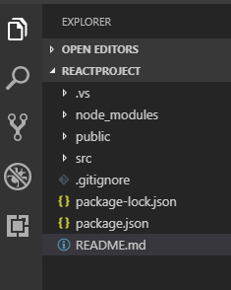

In React application, there are several files and folders in the root directory. Some of them are as follows:

1. **node modules:** It contains the React library and any other third party libraries needed.
2. **public:** It holds the public assets of the application. It contains the index.html where React will mount the application by default on the <div id="root"></div> element.
3. **src:** It contains the App.css, App.js, App.test.js, index.css, index.js, and serviceWorker.js files. Here, the App.js file always responsible for displaying the output screen in React.
4. **package-lock.json:** It is generated automatically for any operations where npm package modifies either the node modules tree or package.json. It cannot be published. It will be ignored if it finds any other place rather than the top-level package.
5. **package.json:** It holds various metadata required for the project. It gives information to npm, which allows to identify the project as well as handle the project?s dependencies.
6. **README.md:** It provides the documentation to read about React topics.

**React Features:**

1. **JSX**

JSX stands for JavaScript XML. It is a JavaScript syntax extension. Its an XML or HTML like syntax used by React JS. This syntax is processed into JavaScript calls of React Framework. It extends the ES6 so that HTML like text can co-exist with JavaScript react code. It is not necessary to use JSX, but it is recommended to use in React JS.

1. **Components**

React JS is all about components. React JS application is made up of multiple components, and each component has its own logic and controls. These components can be reusable which help you to maintain the code when working on larger scale projects.

1. **One-way Data Binding**

React JS is designed in such a manner that follows unidirectional data flow or one-way data binding. The benefits of one-way data binding give you better control throughout the application. If the data flow is in another direction, then it requires additional features. It is because components are supposed to be immutable and the data within them cannot be changed.

1. **Virtual Dom**

A virtual DOM object is a representation of the original DOM object. It works like a one-way data binding. Whenever any modifications happen in the web application, the entire UI is re-rendered in virtual DOM representation. Then it checks the difference between the previous DOM representation and new DOM. Once it has done, the real DOM will update only the things that have actually changed.

1. **Simplicity**

ReactJS uses JSX file which makes the application simple and to code as well as understand. We know that ReactJS is a component-based approach which makes the code reusable as your need. This makes it simple to use and learn.

1. **Performance**

ReactJS is known to be a great performer. This feature makes it much better than other frameworks out there today. The reason behind this is that it manages a virtual DOM. The DOM is a cross-platform and programming API which deals with HTML, XML or XHTML. The DOM exists entirely in memory. Due to this, when we create a component, we did not write directly to the DOM.

**PROS AND CONS OF REACT JS:**

Advantage of React JS:

1. **Easy to learn and use**

React JS is much easier to learn and use. It comes with a good supply of documentation, tutorials, and training resources

1. **Creating Dynamic Web Applications Becomes Easier**

To create a dynamic web application specifically with HTML strings was tricky because it requires a complex coding, but React JS solved that issue and makes it easier. It provides less coding and gives more functionality. It makes use of the JSX(JavaScript Extension), which is a particular syntax letting HTML quotes.

1. **Reusable Components**

A ReactJS web application is made up of multiple components, and each component has its own logic and controls. These components are responsible for outputting a small and reusable code helps to make your apps easier to develop and maintain.

1. **Performance Enhancement**

ReactJS improves performance due to virtual DOM. The DOM is a cross-platform and programming API which deals with HTML, XML or XHTML. Most of the developers faced the problem when the DOM was updated, which slowed down the performance of the application. ReactJS solved this problem by introducing virtual DOM.

1. **The Support of Handy tools**

React JS has also gained popularity due to the presence of a handy set of tools. These tools make the task of the developers understandable and easier. The React Developer Tools have been designed as Chrome and Firefox dev extension and allow you to inspect the React component hierarchies in the virtual DOM.

1. **Known to be SEO Friendly**

Traditional JavaScript frameworks have an issue in dealing with SEO. The search engines generally having trouble in reading JavaScript-heavy applications. Many web developers have often complained about this problem. ReactJS overcomes this problem that helps developers to be easily navigated on various search engines.

1. **The Benefit of Having JavaScript Library**

Today, ReactJS is choosing by most of the web developers. It is because it is offering a very rich JavaScript library. The JavaScript library provides more flexibility to the web developers to choose the way they want.

Disadvantage of React JS:

1. **The high pace of development**

The high pace of development has an advantage and disadvantage both. In case of disadvantage, since the environment continually changes so fast, some of the developers not feeling comfortable to relearn the new ways of doing things regularly.

1. **Poor Documentation**

It is another cons which are common for constantly updating technologies. React technologies updating and accelerating so fast that there is no time to make proper documentation.

1. **View part**

ReactJS Covers only the UI Layers of the app and nothing else. So you still need to choose some other technologies to get a complete tooling set for development in the project.

1. **JSX as a barrier**

ReactJS uses JSX. It's a syntax extension that allows HTML with JavaScript mixed together. This approach has its own benefits, but some members of the development community consider JSX as a barrier, especially for new developers. Developers complain about its complexity in the learning curve.

**React JS VS Angular JS:**

|  |  |  |
| --- | --- | --- |
|  | **Angular JS** | **React JS** |
| **Author** | Google | Facebook Community |
| **Developer** | Misko Hevery | Jordan Walke |
| **Initial Release** | October2010 | March 2013 |
| **Latest Version** | Angular  **16.0.3** / 24 May 2023 | React  **18.0.16** |
| **Language** | JavaScript, HTML | JSX |
| **Type** | Open Source MVC Framework | Open Source JS |
| **Rendering** | Client-Side | Server-Side |
| **Packaging** | Weak | Strong |
| **Data-Binding** | Bi-directional | Uni-directional |
| **Dom** | Regular DOM | Virtual DOM |
| **Testing** | Unit and Integration Testing | Unit Testing |
| **App Architecture** | MVC | Flux |
| **Dependencies** | It manages dependencies automatically. | It requires additional tools to manage dependencies. |
| **Routing** | It requires a template or controller to its router configuration, which has to be managed manually. | It doesn’t handle routing but has a lot of modules for routing eg: react-router |
| **Performance** | Slow | Fast, due to virtual DOM. |
| **Best For** | It is best for single page applications that update a single view at a time | It is best for single page applications that update multiple views at a time |

**React JS VS React Native:**

|  |  |
| --- | --- |
| **React JS** | **React Native** |
| The ReactJS initial release was in 2013. | The React Native initial release was in 2015. |
| It is used for developing web applications. | It is used for developing mobile applications. |
| It can be executed on all platforms. | It is not platform independent. It takes more effort to be executed on all platforms. |
| It uses a JavaScript library and CSS for animations. | It comes with built-in animation libraries. |
| It uses React-router for navigating web pages. | It has built-in Navigator library for navigating mobile applications. |
| It uses HTML tags. | It does not use HTML tags. |
| It can use code components, which saves a lot of valuable time. | It can reuse React Native UI components & modules which allow hybrid apps to render natively. |
| It provides high security. | It provides low security in comparison to ReactJS. |

**React VS Vue:**

|  |  |  |
| --- | --- | --- |
|  | **React** | **Vue** |
| **Definition** | React is a declarative, efficient, flexible, open-source JavaScript library for building reusable UI components. | Vue is an open-source JavaScript library for building reusable user interfaces and single-page applications. |
| **History** | It was created by Jordan Walke, a software engineer at Facebook. It was initially developed and maintained by Facebook and later used in its products like WhatsApp & Instagram. | Vue was created by Evan You, a former employee of Google worked on many Angular projects. He wanted to make a better version of Angular, just extracting the part which he liked about Angular and making it lighter. |
| **Preferred Language** | JavaScript/JavaScript XML | HTML/JavaScript |
| **Size** | The size of the React library is 100 kilobytes (approx.). | The size of the Vue library is 60 kilobytes (approx.). |
| **Performance** | Its performance is slow as compared to Vue. | Its performance is fast as compared to React. |
| **Flexibility** | React provides great flexibility to support third-party libraries. | Vue provides limited flexibility as compared to React. |
| **Current Version** | React  **18.0.16** | vue  **3.3.4** (18 May 2023) |
| **Long Term Support** | It is suitable for long term supports. | It is not suitable for long term support. |

**React JSX**

JSX provides you to write HTML/XML-like structures (e.g., DOM-like tree structures) in the same file where you write JavaScript code, then pre-processor will transform these expressions into actual JavaScript code. Just like XML/HTML, JSX tags have a tag name, attributes, and children.

Why use JSX?

* It is faster than regular JavaScript because it performs optimization while translating the code to JavaScript
* Instead of separating technologies by putting markup and logic in separate files, React uses components that contain both.
* It is type-safe, and most of the errors can be found at compilation time.
* It makes easier to create templates.

**Nested Elements in JSX:**

**App.js**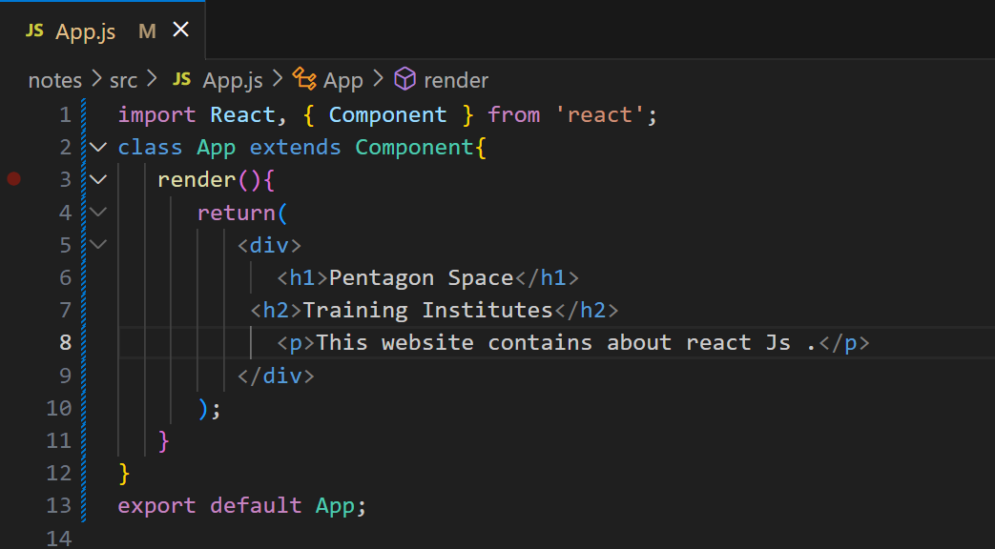

**Output:**

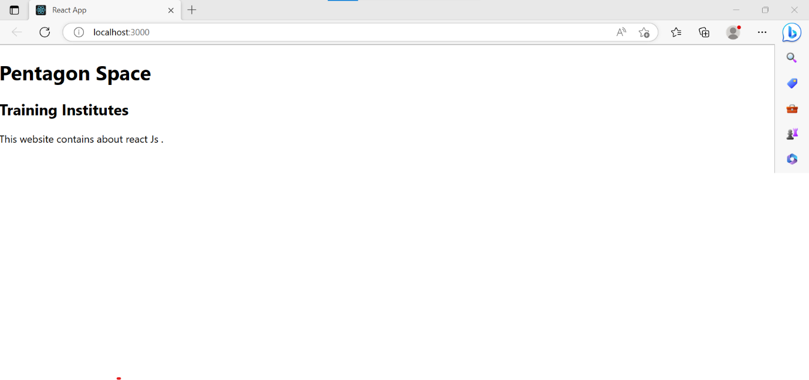

**JSX Attributes:**

JSX use attributes with the HTML elements same as regular HTML. JSX uses **camel case** naming convention for attributes rather than standard naming convention of HTML such as a class in HTML becomes **class Name** in JSX because the class is the reserved keyword in JavaScript. We can also use our own custom attributes in JSX. For custom attributes, we need to use **data- prefix**.

**App.js**

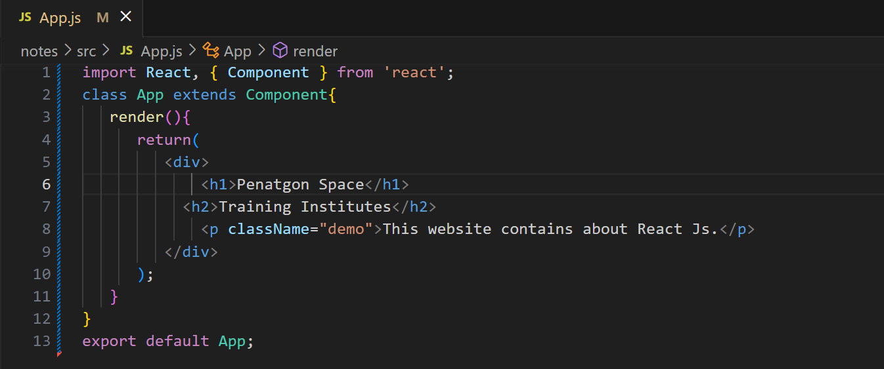

**In JSX,** **we can specify attribute values in two ways:**

1. **As String Literals:**

We can specify the values of attributes in double quotes

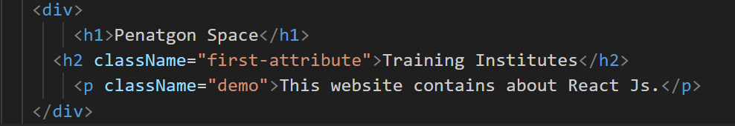**Example:**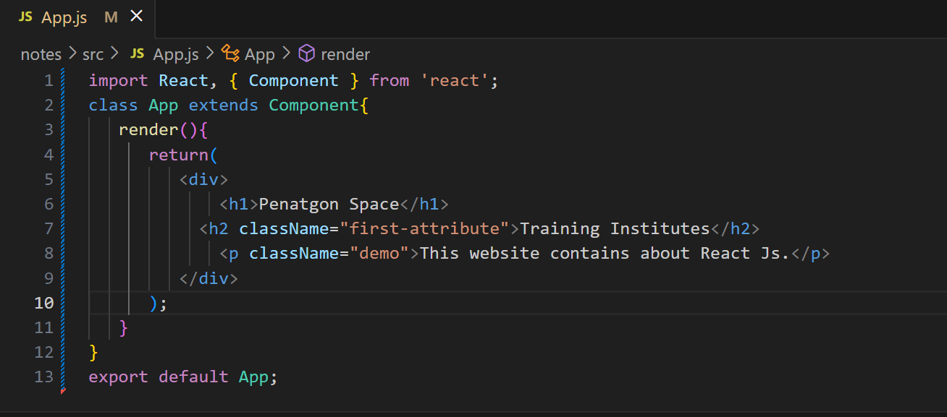

1. **As Expressions:**

We can specify the values of attributes as expressions using curly braces {}.

**Example:**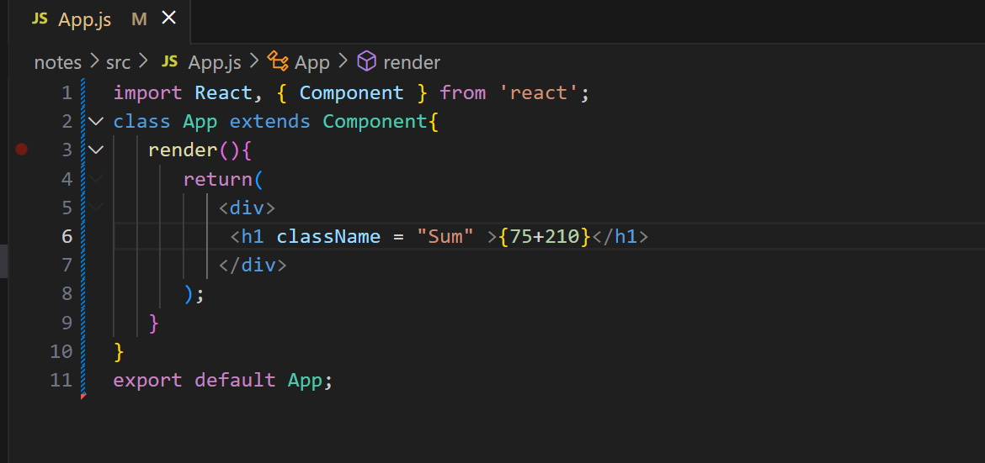

**Output:**

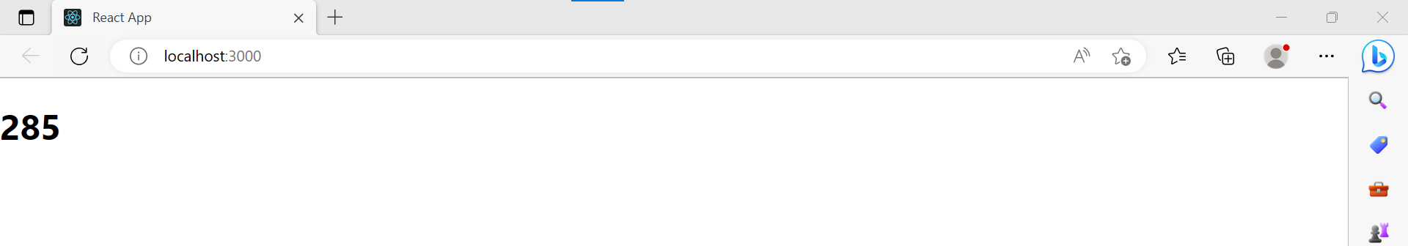

**JSX Comments:**

JSX allows us to use comments that begin with /* and ends with */ and wrapping them in curly braces {} just like in the case of JSX expressions.

**Example:**

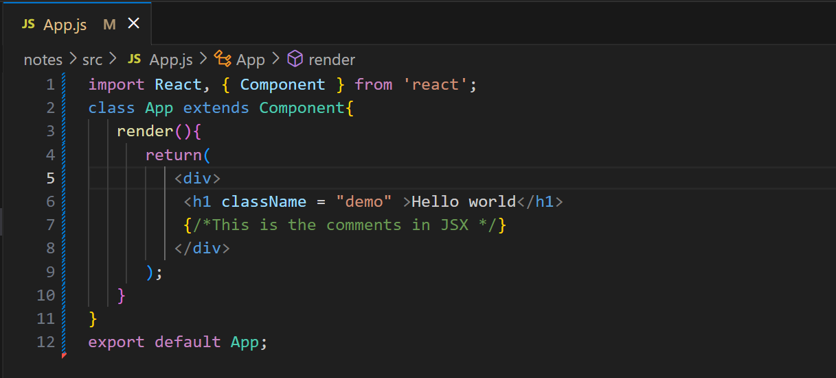

**JSX Styling:**

React always recommends to use **inline** styles. To set inline styles, you need to use **camel Case** syntax. React automatically allows appending **px** after the number value on specific elements.

**Example:**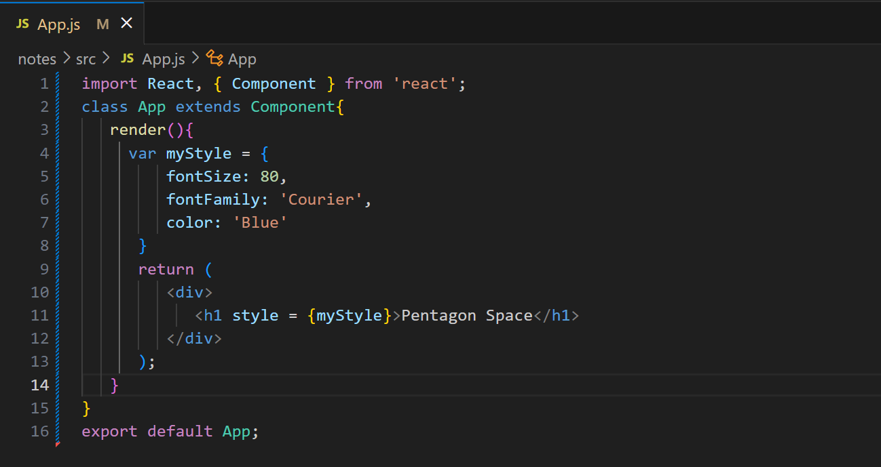

**Output:**

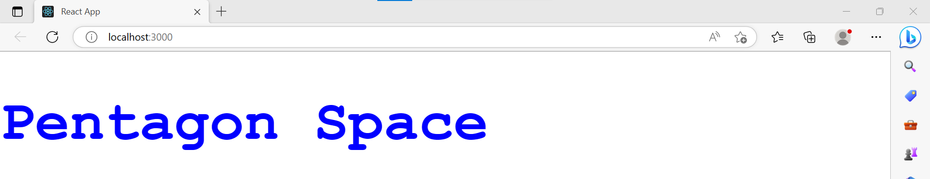

**React Components:**

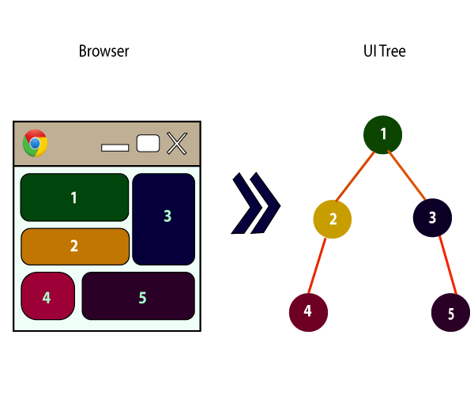

In React JS, we have mainly two types of components. They are

1. **Functional Component**
2. **Class Components**

**Functional Components:**

In React, function components are a way to write components that only contain a render method and don't have their own state. They are simply JavaScript functions that may or may not receive data as parameters. We can create a function that takes props(properties) as input and returns what should be rendered.

**Example:** 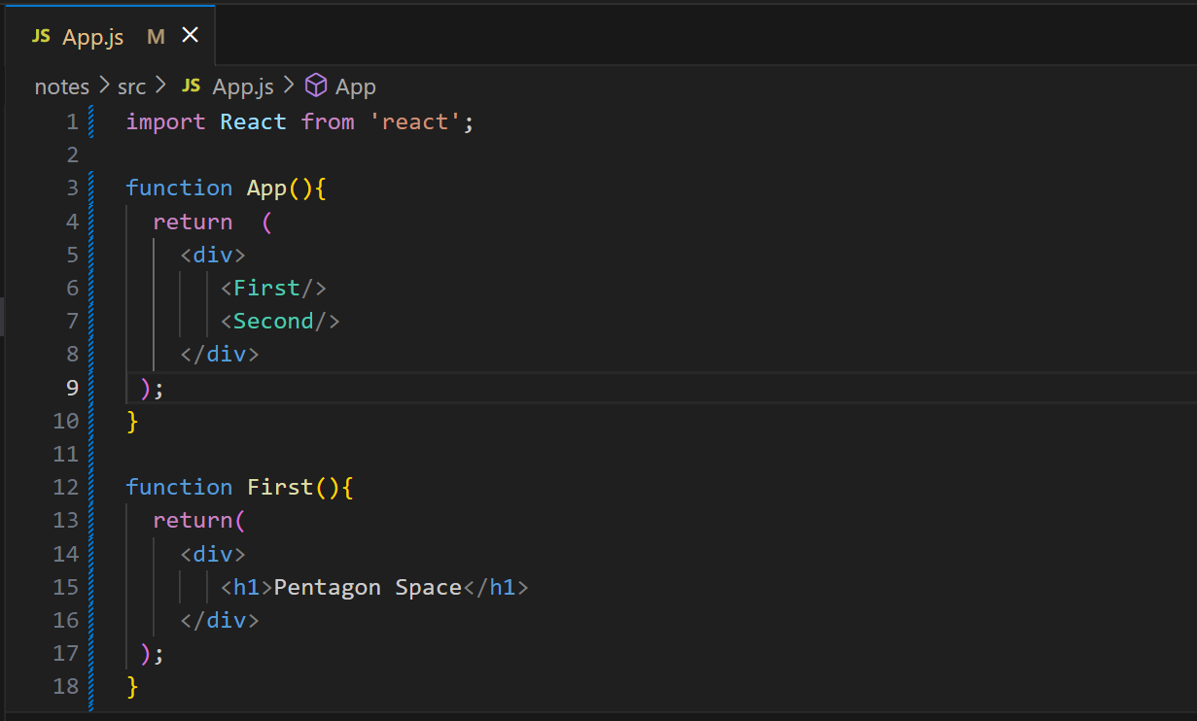

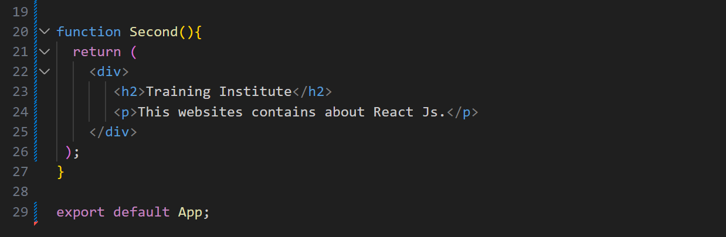

**Output:**

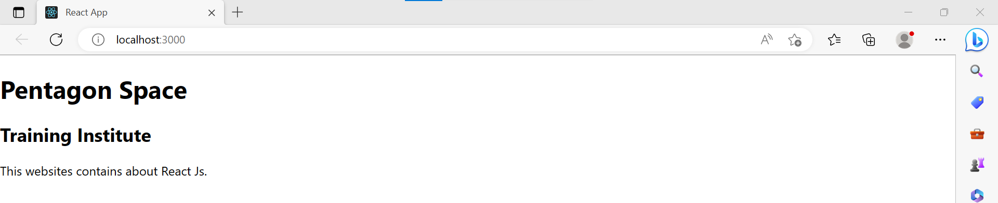

**Class Components:**

Class components are more complex than functional components. It requires you to extend from React. Component and create a render function which returns a React element. You can pass data from one class to other class components.

**Example:**

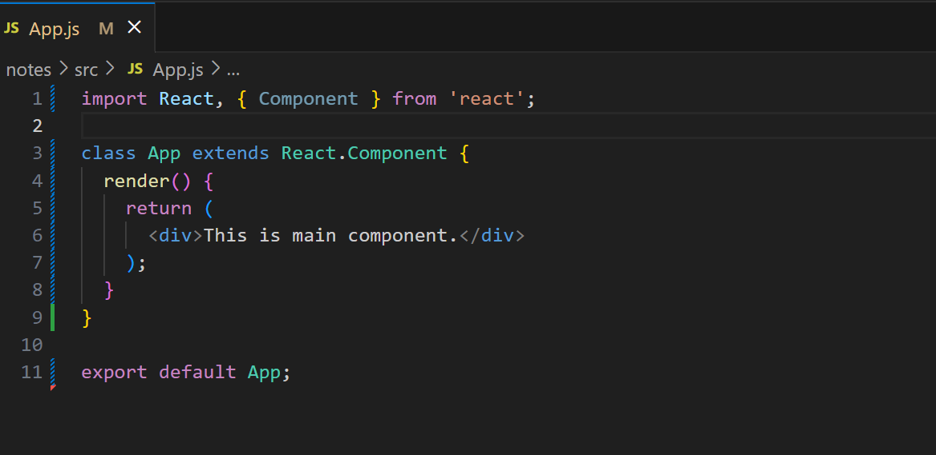

**Output:**

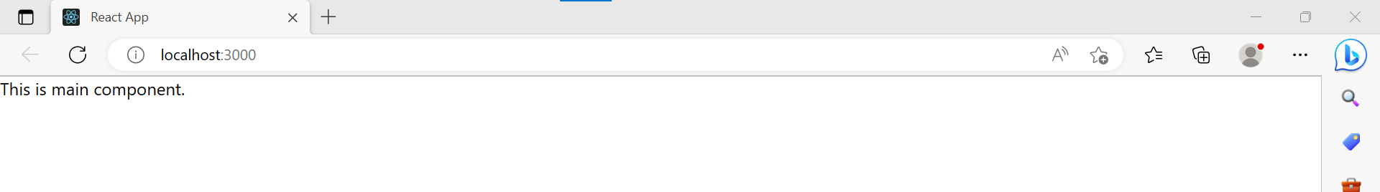

**Example 2:**

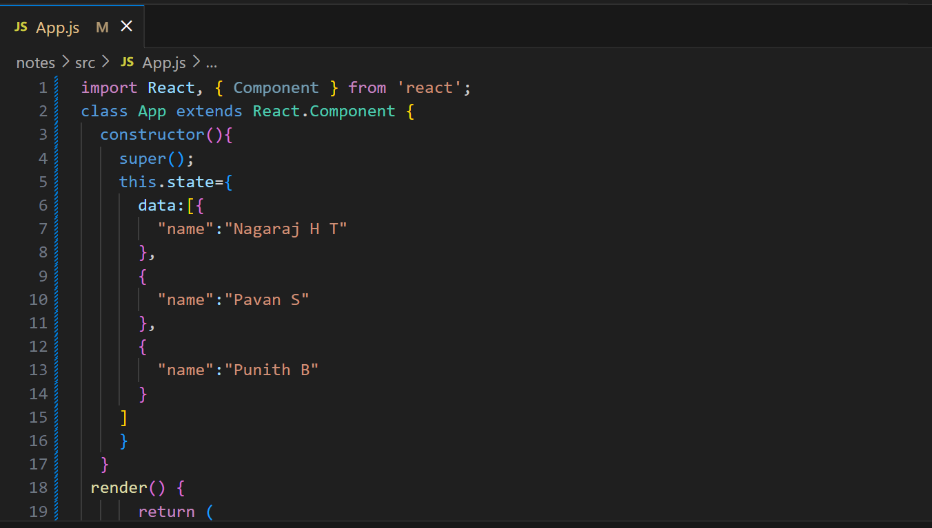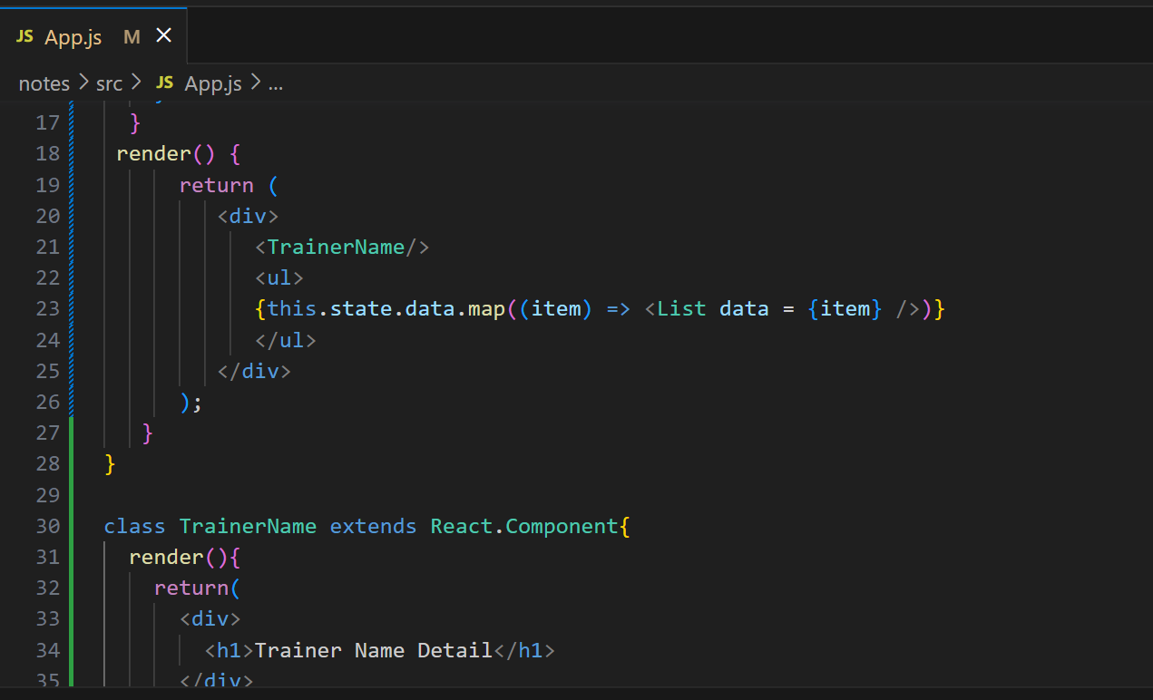

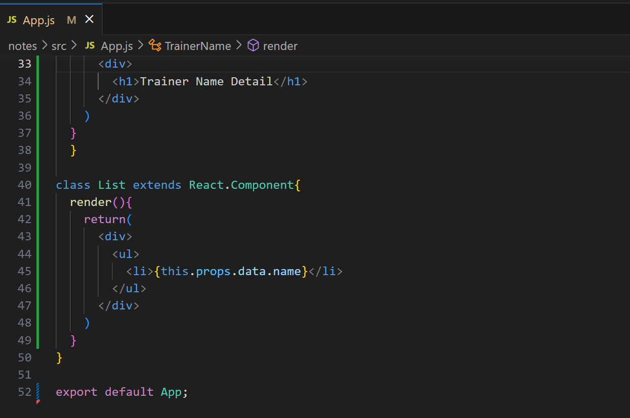

**Output:**

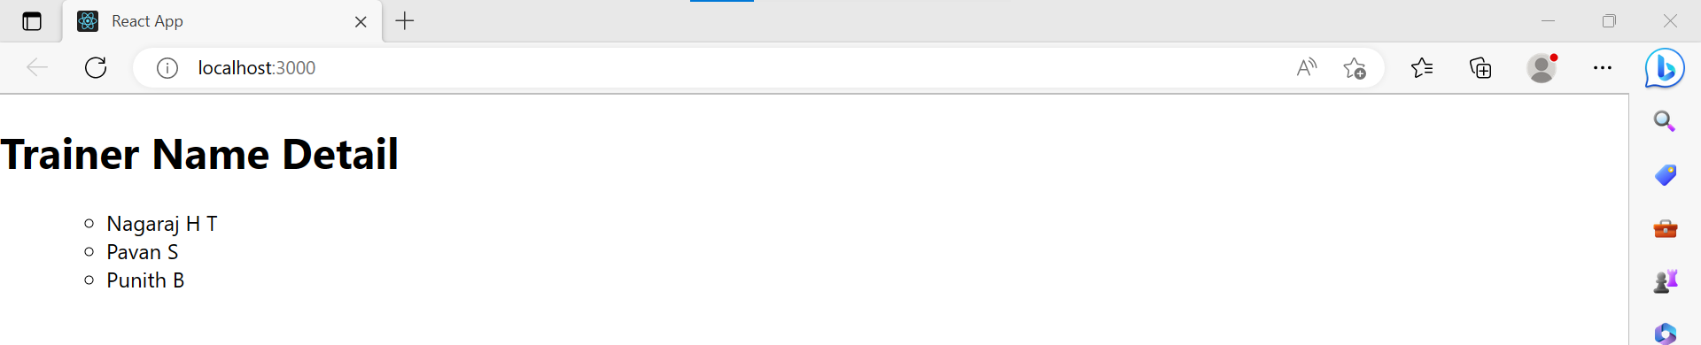

**React State:**

The state is an updatable structure that is used to contain data or information about the component. The state in a component can change over time. The change in state over time can happen as a response to user action or system event.

A state must be kept as simple as possible. It can be set by using the **setState()** method and calling setState() method triggers UI updates. A state represents the component's local state or information. It can only be accessed or modified inside the component or by the component directly. To set an initial state before any interaction occurs, we need to use the **getInitialState()** method.

**Defining State:**

To define a state, you have to first declare a default set of values for defining the component's initial state.

**Example:**

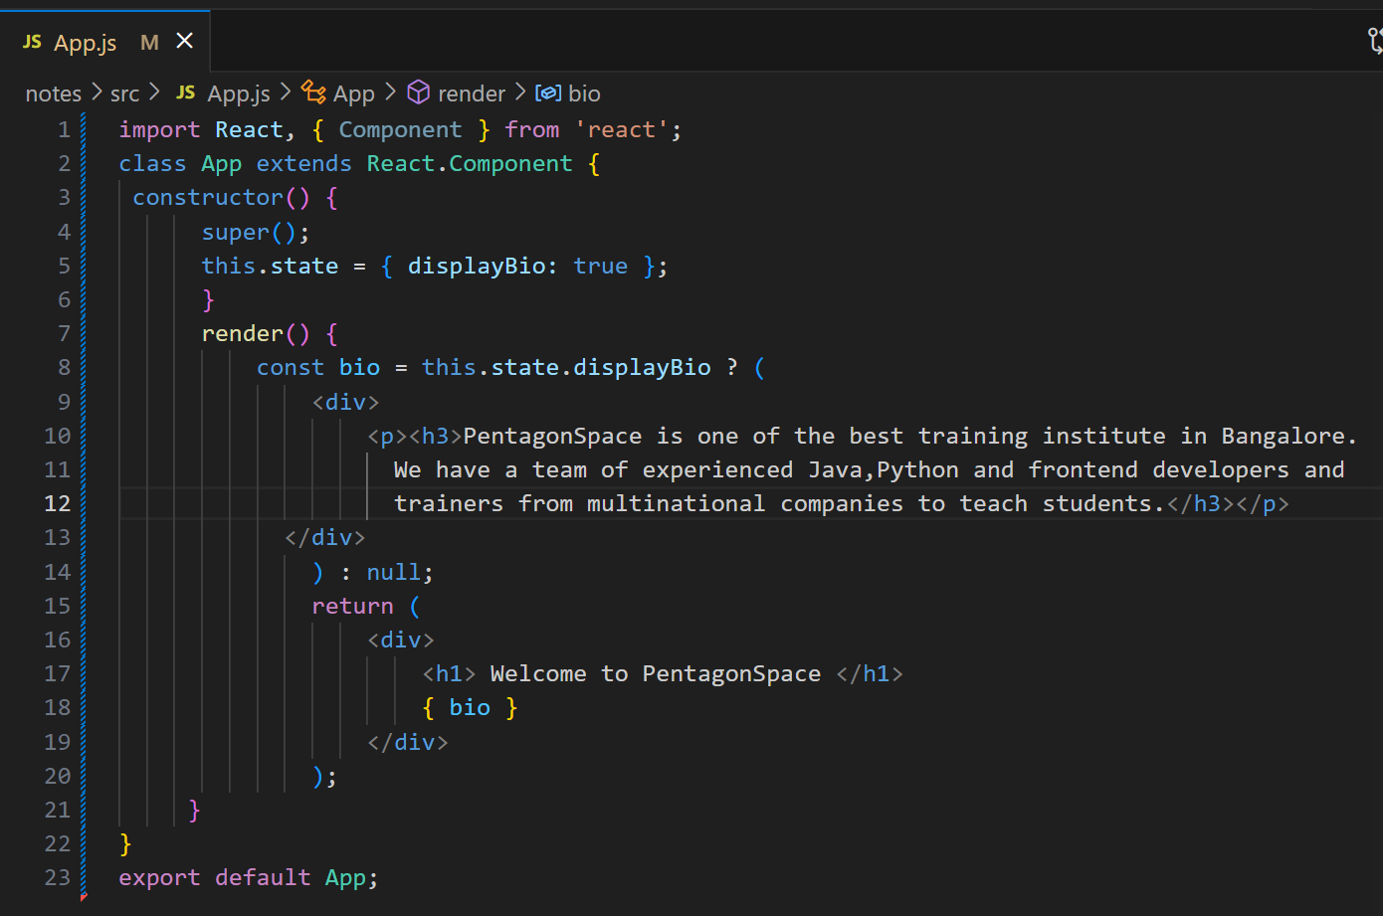

**Output:**

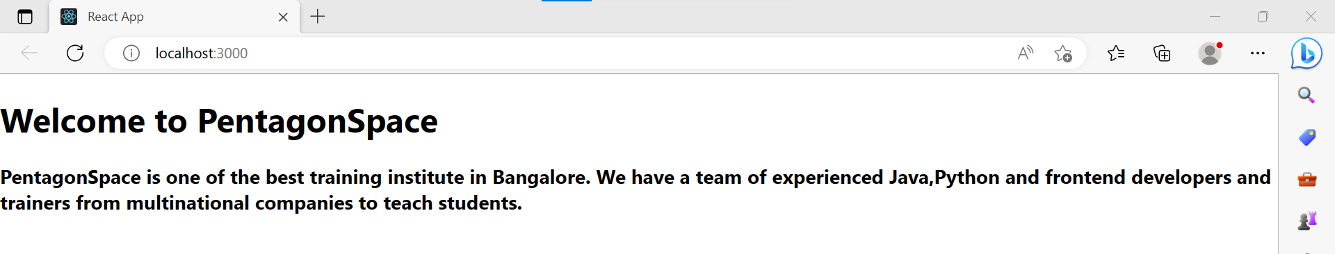

**Changing the State:**

We can change the component state by using the setState() method and passing a new state object as the argument.

**Example:**

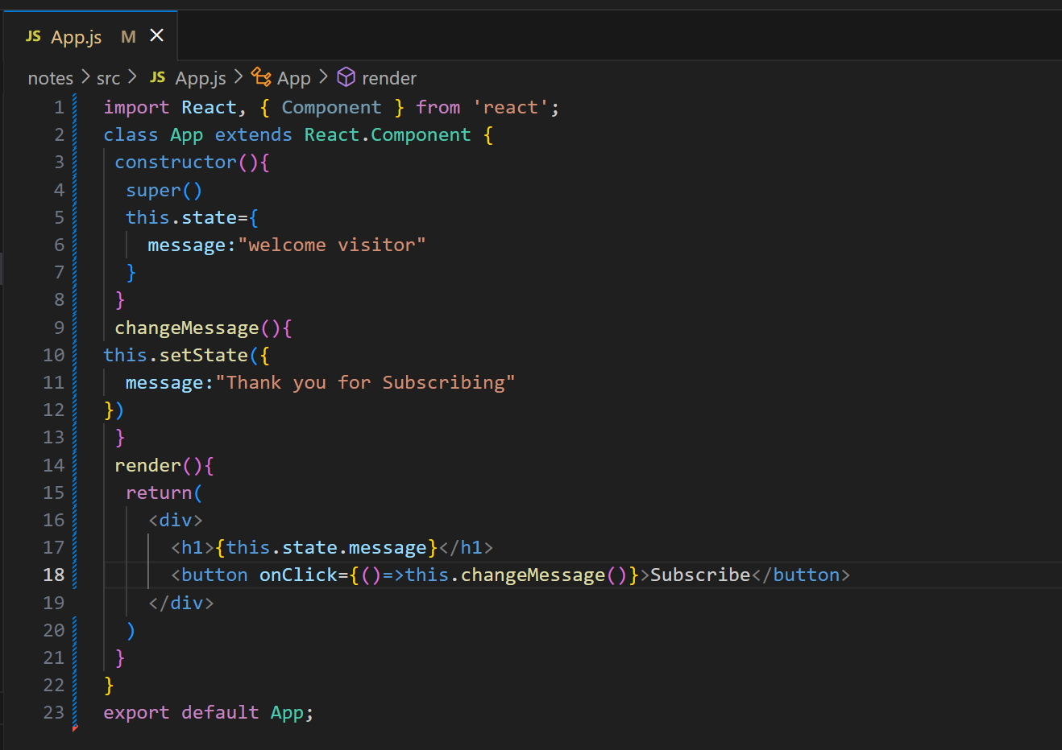

**Output:**

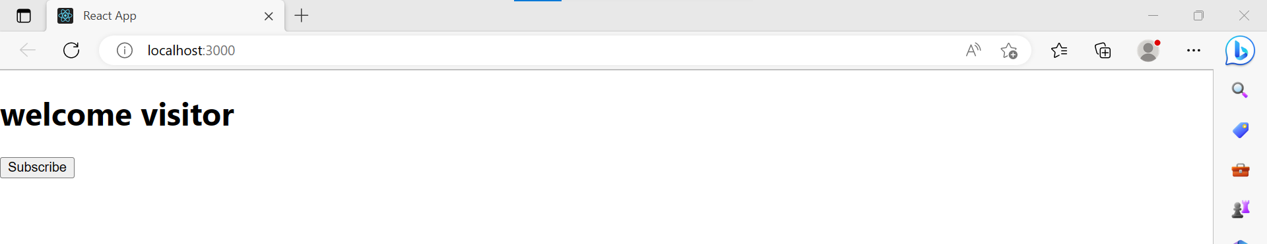

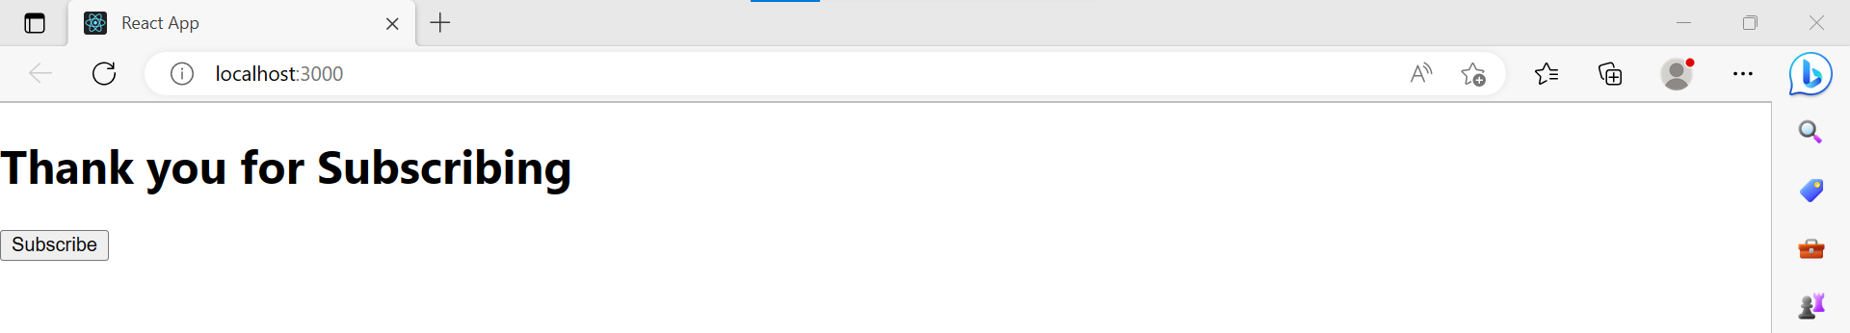

**React Props:**

Props stand for "**Properties**." They are **read-only** components. It is an object which stores the value of attributes of a tag and work similar to the HTML attributes.

Props are **immutable** so we cannot modify the props from inside the component.

**Example:**

**App.js**

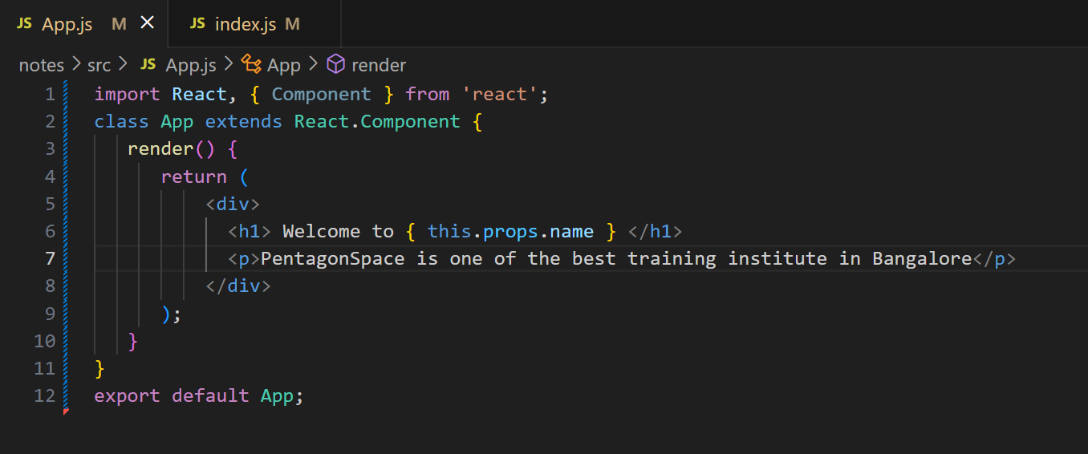

**index.js**

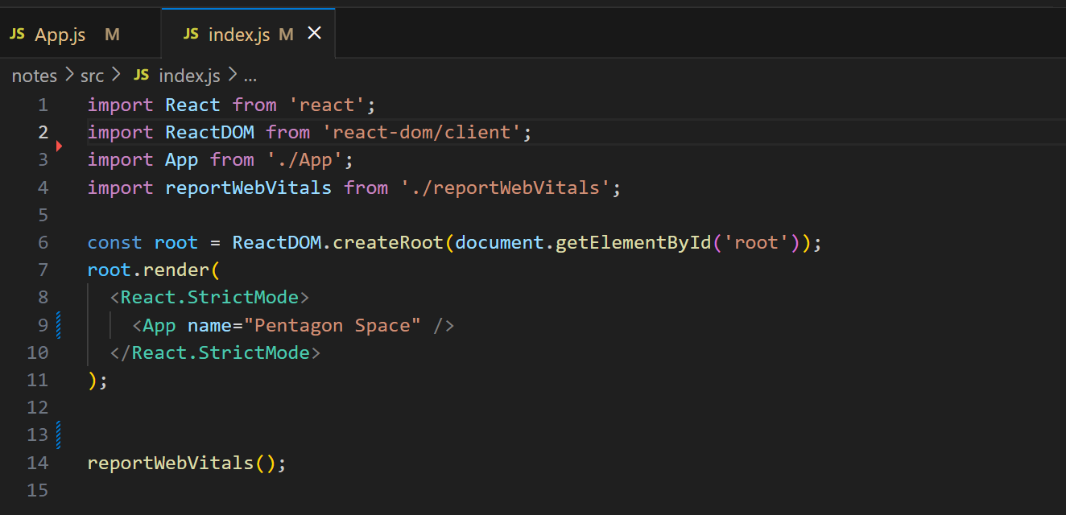

**Output:**

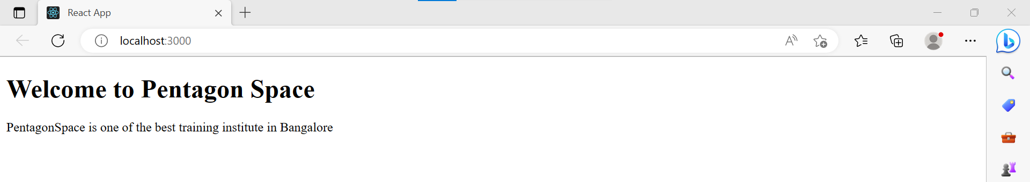

**Default Props:**

It is not necessary to always add props in the reactDom.render() element. You can also set **default** props directly.

**Example:**

**App.js**

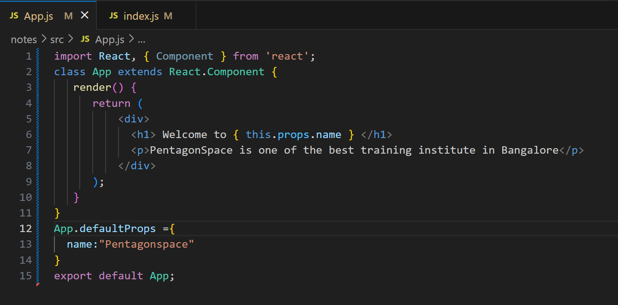

**index.js**

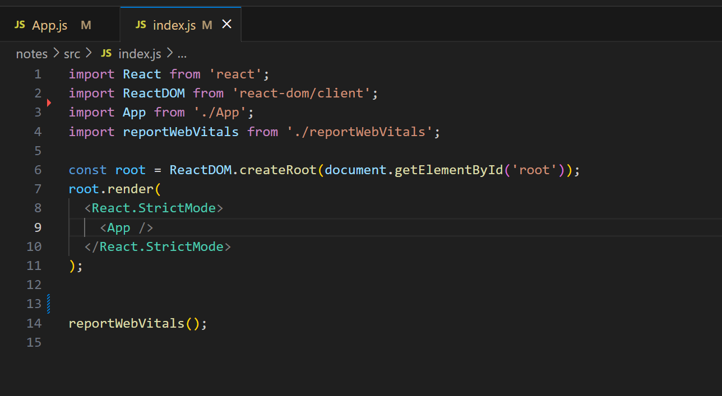

**Output:**

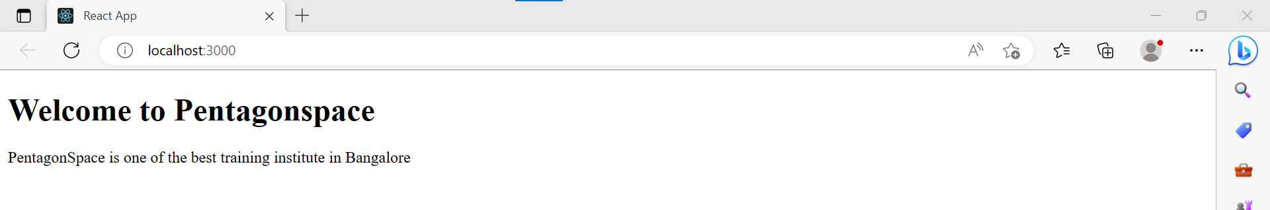

**State and Props:**

It is possible to combine both state and props in your app. You can set the state in the parent component and pass it in the child component using props.

**Example:**

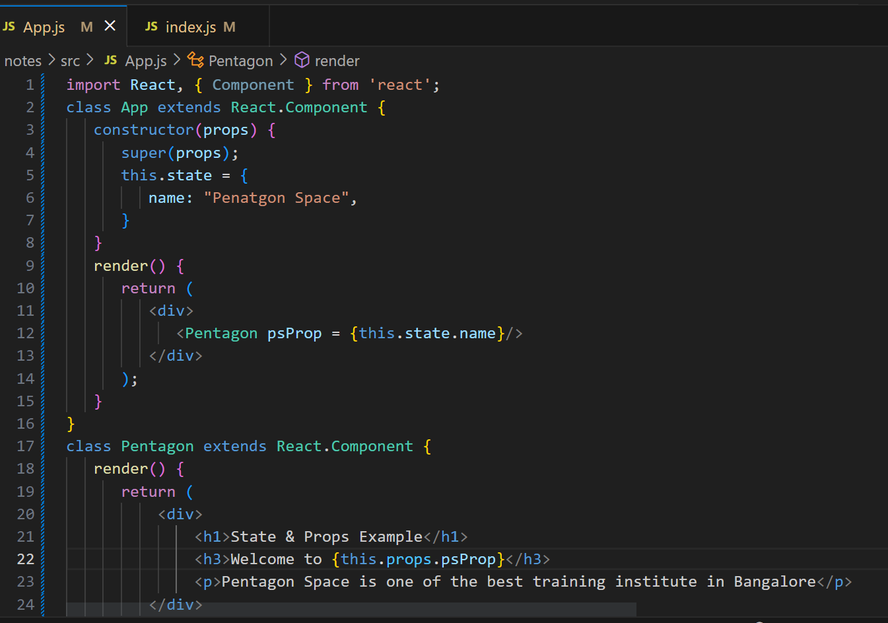

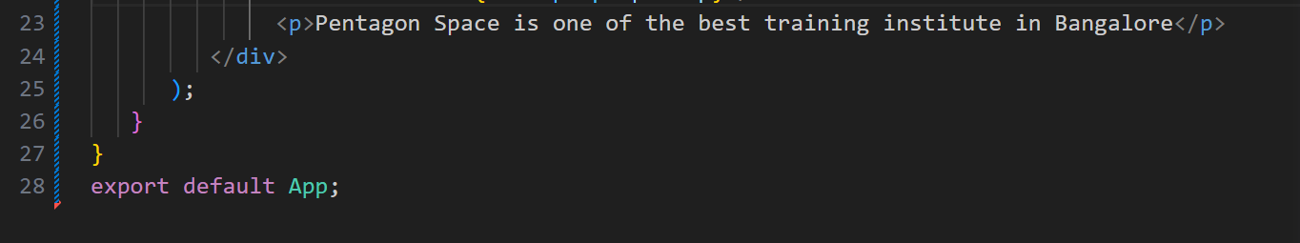

**Output:**

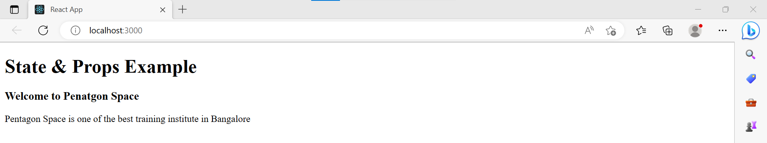

**React Props Validation:**

Props are an important mechanism for passing the **read-only** attributes to React components. The props are usually required to use correctly in the component.

**Validating Props:**

**App.propTypes** is used for props validation in react component. When some of the props are passed with an invalid type, you will get the warnings on JavaScript console. After specifying the validation patterns

**Syntax:**

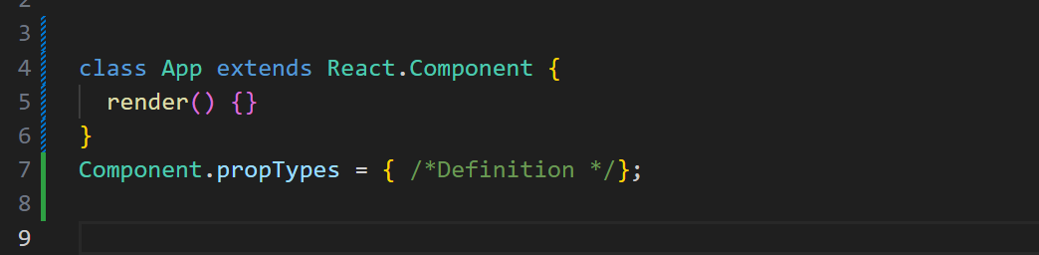

**React JS Props Validator:**

|  |  |
| --- | --- |
| **PropsType** | **Description** |
| PropTypes.any | The props can be of any data type. |
| PropTypes.array | The props should be an array. |
| PropTypes.bool | The props should be a boolean. |
| PropTypes.func | The props should be a function. |
| PropTypes.number | The props should be a number. |
| PropTypes.object | The props should be an object. |
| PropTypes.string | The props should be a string. |
| PropTypes.symbol | The props should be a symbol. |
| PropTypes.instanceOf | The props should be an instance of a particular JavaScript class. |
| PropTypes.isRequired | The props must be provided. |
| PropTypes.element | The props must be an element. |
| PropTypes.node | The props can render anything: numbers, strings, elements or an array (or fragment) containing these types. |
| PropTypes.oneOf() | The props should be one of several types of specific values. |
| PropTypes.oneOfType([PropsTypes.string,PropTypes.number]) | The props should be an object that could be one of many types. |

**React JS Custom Validators:**

React JS allows creating a custom validation function to perform custom validation. The following argument is used to create a custom validation function.

* **props:** It Should be the first argument in the component.
* **propName:** It is the propName that is going to validate.
* **componentName:** It is the componentName that are going to validated again.

**Difference between State and Props:**

|  |  |
| --- | --- |
| **Props** | **State** |
| Props are read-only. | State changes can be asynchronous. |
| Props are immutable. | State is mutable. |
| Props allow you to pass data from one component to other components as an argument. | State holds information about the components. |
| Props can be accessed by the child component. | State cannot be accessed by child components. |
| Props are used to communicate between components. | States can be used for rendering dynamic changes with the component. |
| Stateless component can have Props. | Stateless components cannot have State. |
| Props make components reusable. | components reusable. State cannot make components reusable. |
| Props are external and controlled by whatever renders the component. | The State is internal and controlled by the React Component itself. |

|  |  |
| --- | --- |
| **SN** | **State and Props** |
|  | Both are plain JS object |
|  | Both can contain default values |
|  | Both are read only when they are using by this |

**What is Constructor:**

The constructor is a method used to initialize an object's state in a class. It automatically called during the creation of an object in a class.

**Syntax:**

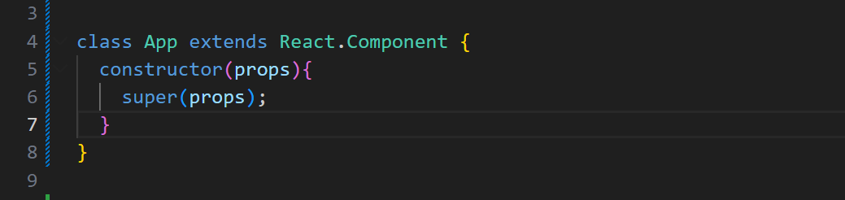

In React, constructors are mainly used for two purposes:

1. It used for initializing the local state of the component by assigning an object to this.state.
2. It used for binding event handler methods that occur in your component.

**Example:**

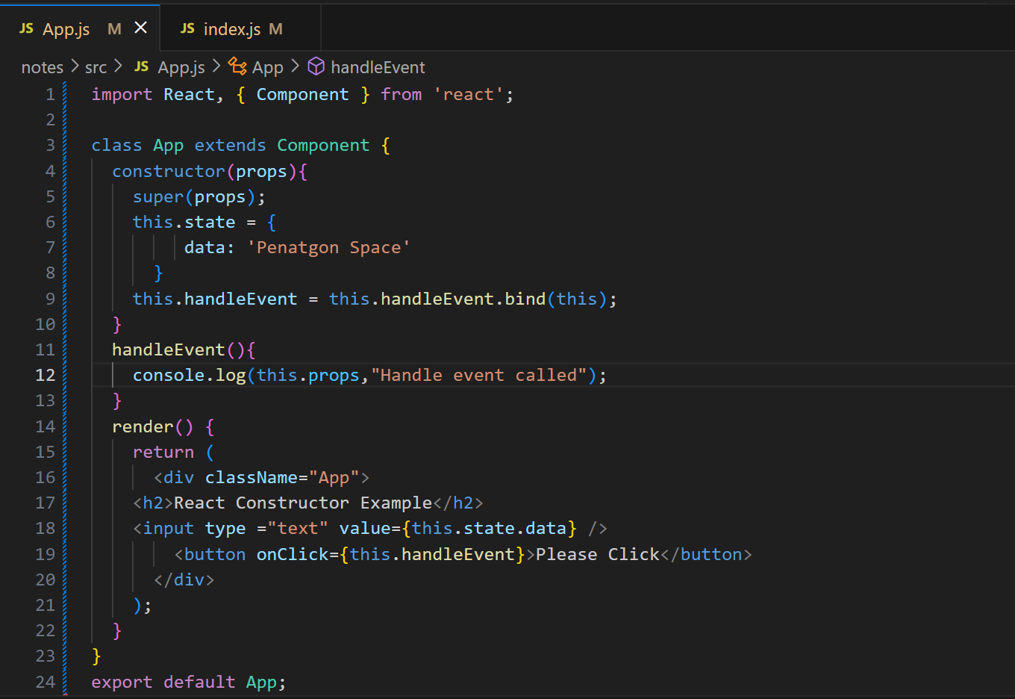

**Output:**

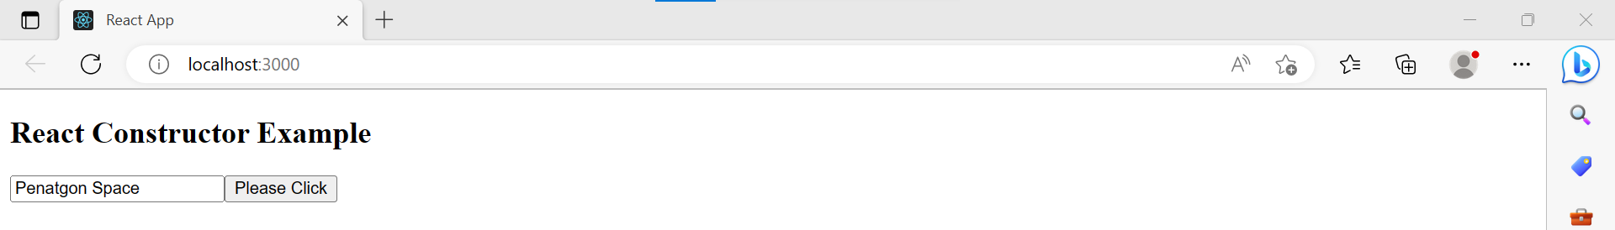

**Arrow Function:**

The Arrow function is the new feature of the ES6 standard. If you need to use arrow functions, it is not necessary to bind any event to 'this.'

**Example:**

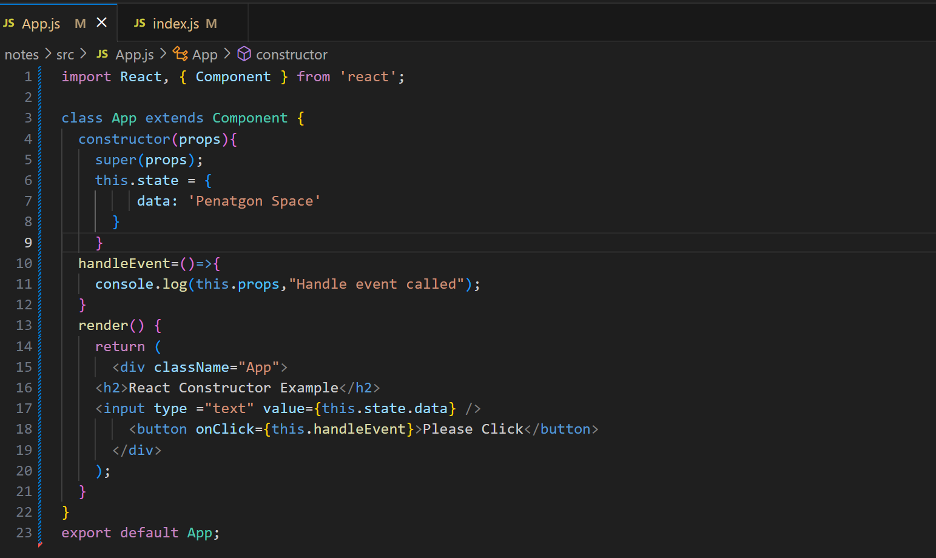

**Output:**



**React Component API:**

React JS component is a top-level API. It makes the code completely individual and reusable in the application. It includes various methods for:

* Creating elements
* Transforming elements
* Fragments
* **setState( ):**

This method is used to update the state of the component. This method does not always replace the state immediately. Instead, it only adds changes to the original state. It is a primary method that is used to update the user interface(UI) in response to event handlers and server responses.

**Syntax:**

this.stateState(object newState[, function callback]);

**Example:**

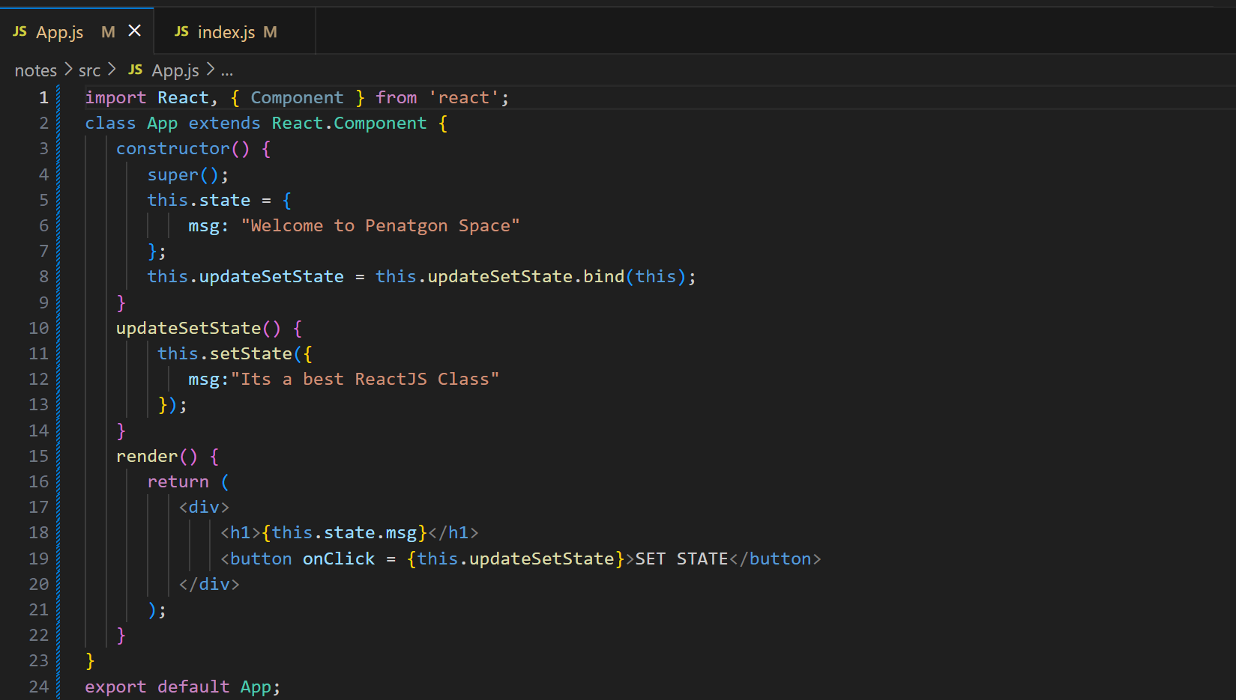

**Output:**

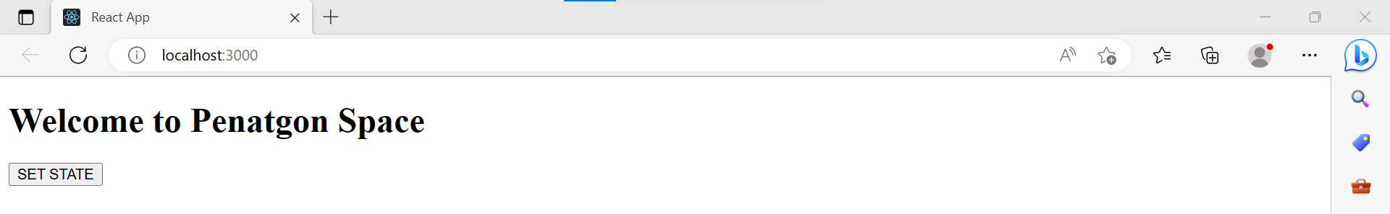

When you click on the SET STATE button, you will see the following screen with the updated message.

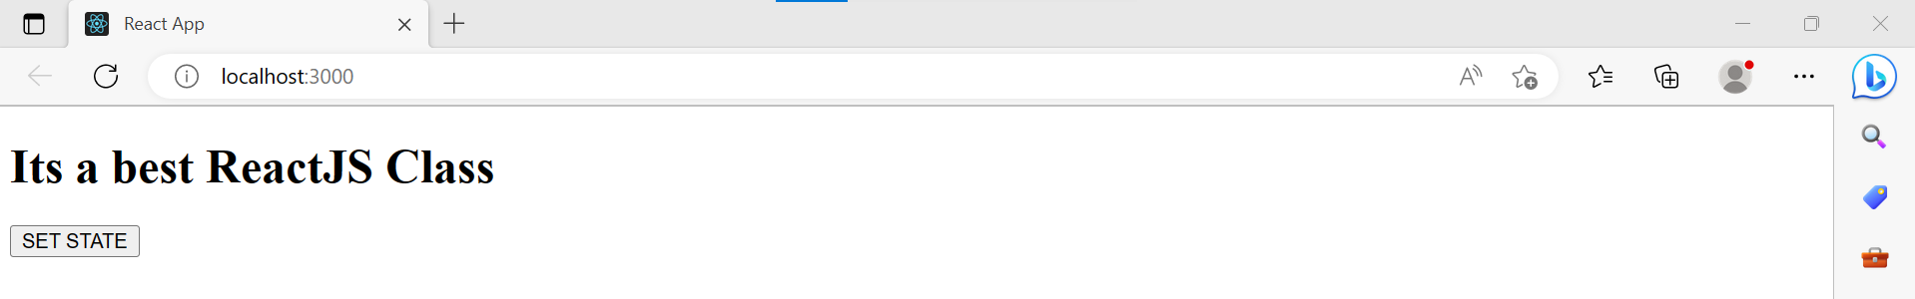

* **forceUpdate( ):**

This method allows us to update the component manually.

**Syntax:**

Component.forceUpdate(callback);

**Example:**

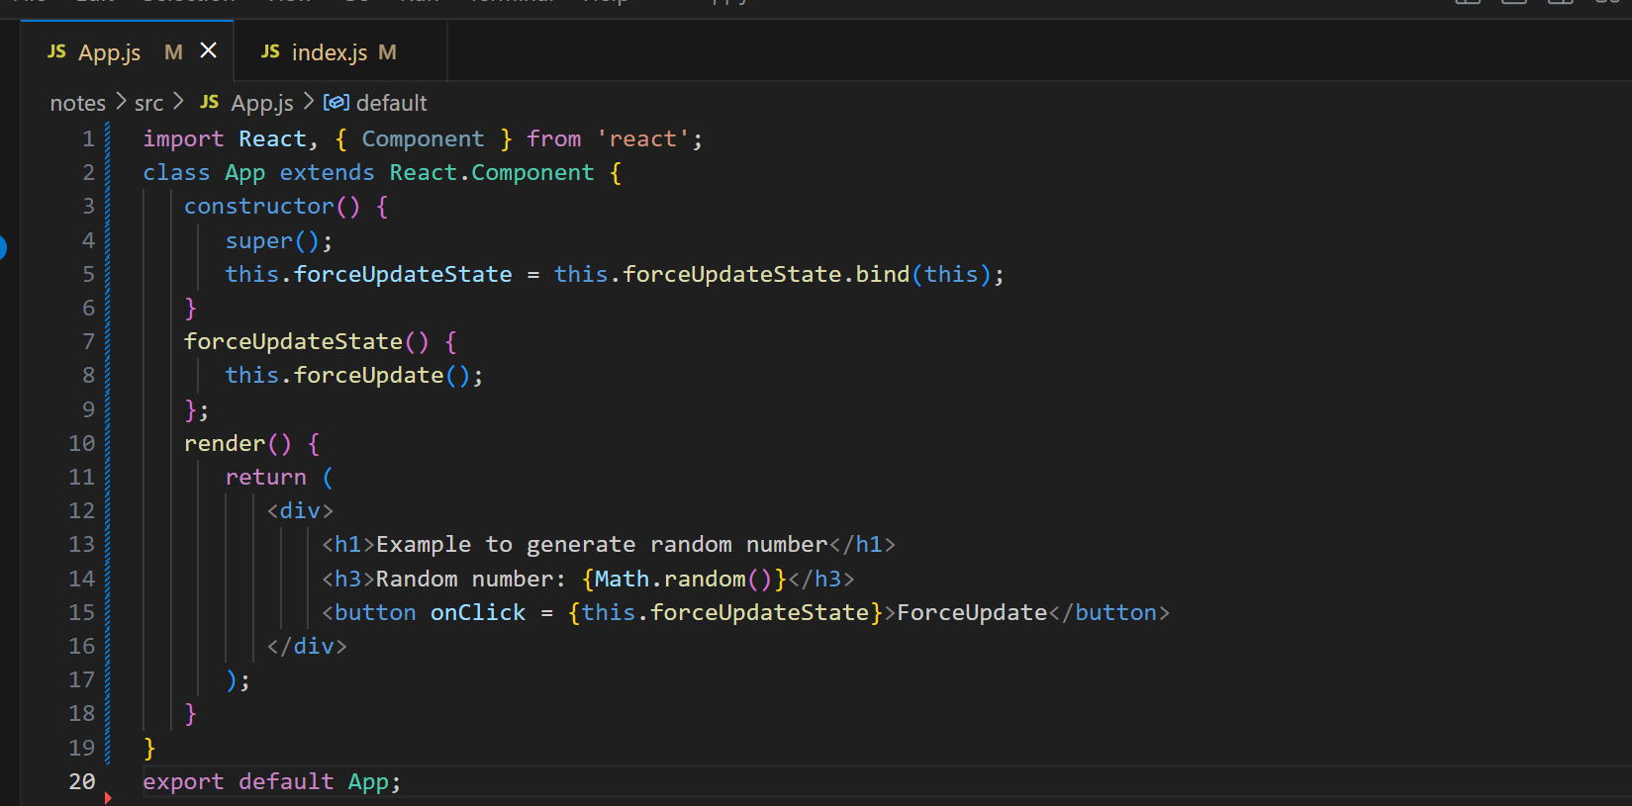

**Output:**

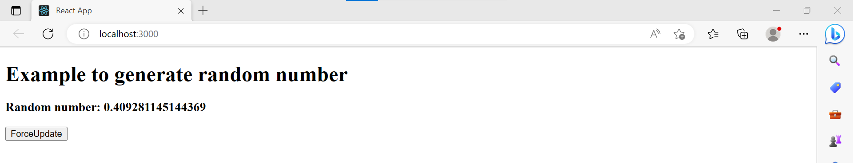

Each time when you click on ForceUpdate button, it will generate the random number. It can be shown in the below image.

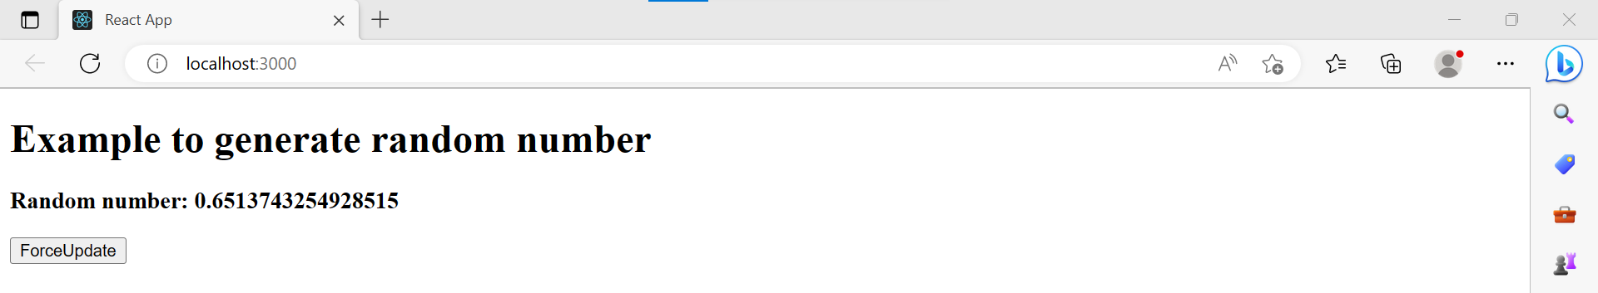

* **forceUpdate( ):**

For DOM manipulation, you need to use ReactDOM.findDOMNode() method. This method allows us to find or access the underlying DOM node.

**Syntax:**

ReactDOM.findDOMNode(component);

**Example:**

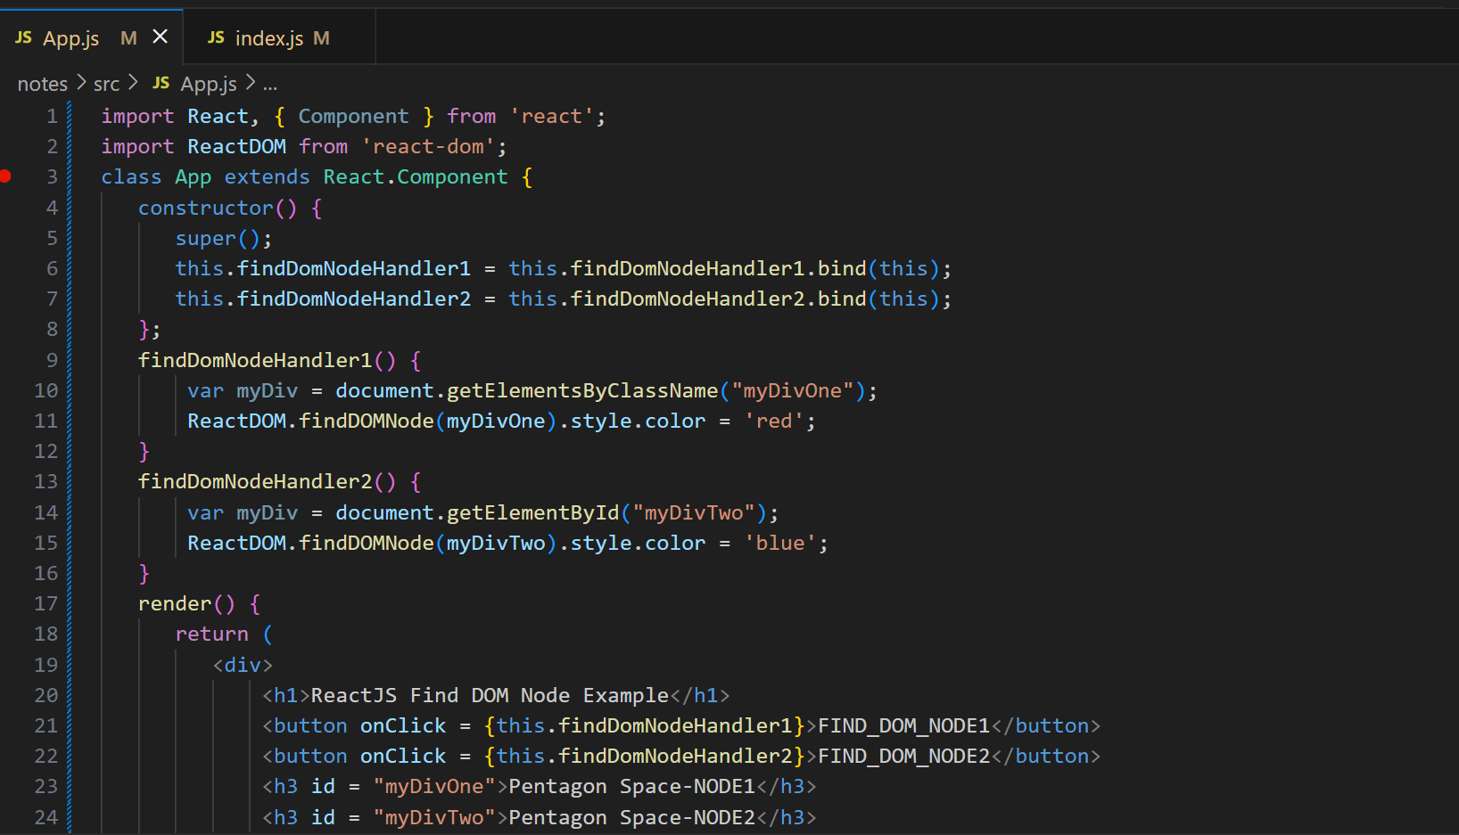

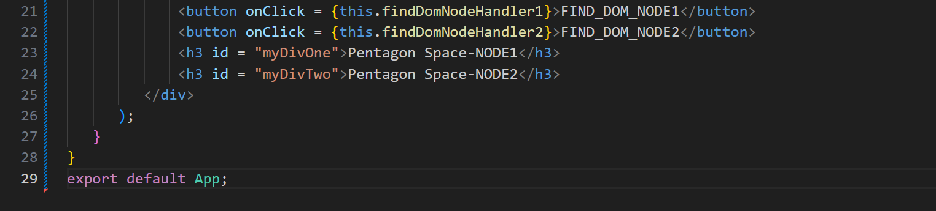

**Output:**

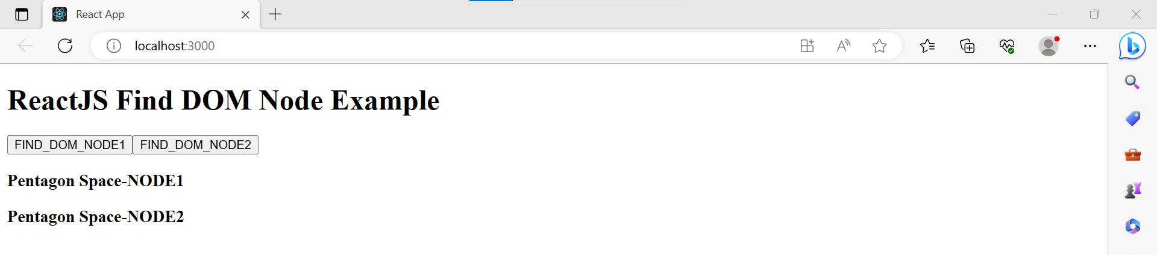

Once you click on the **button**, the color of the node gets changed.

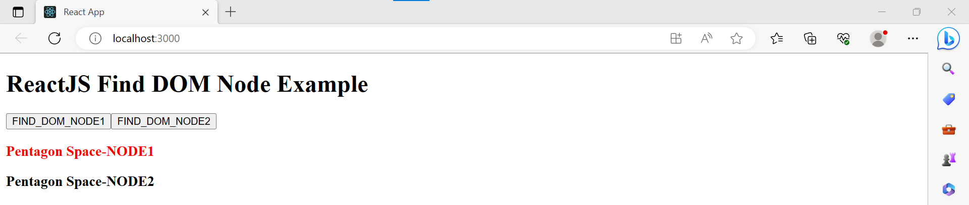

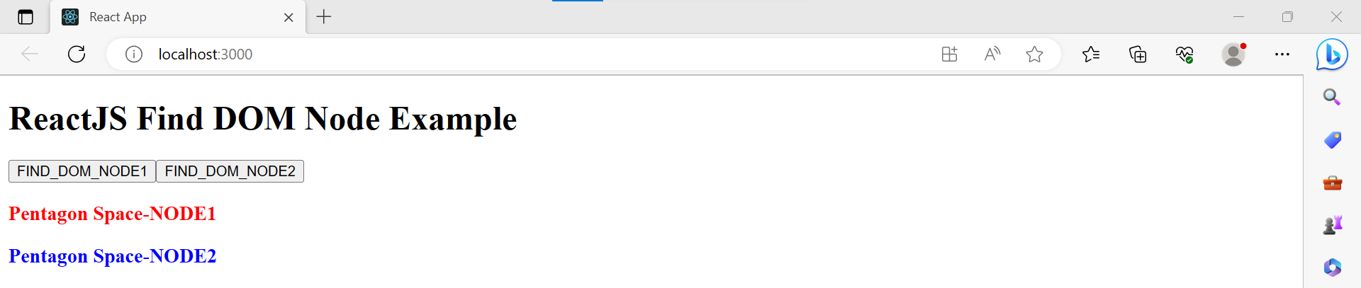

**React Component Life-Cycle:**

In ReactJS, every component creation process involves various lifecycle methods. These lifecycle methods are termed as component's lifecycle. These lifecycle methods are not very complicated and called at various points during a component's life.

**The lifecycle of the component is divided into four phases.**

* Initial Phase
* Mounting Phase
* Updating Phase
* Unmounting Phase

1. **Initial Phase**

* **getDefaultProps():**

It is used to specify the default value of this.props. It is invoked before the creation of the component or any props from the parent is passed into it.

* **getInitialState():**

It is used to specify the default value of this.state. It is invoked before the creation of the component.

1. **Mounting Phase**

* **componentWillMount():**

This is invoked immediately before a component gets rendered into the DOM. In the case, when you call **setState()** inside this method

* **componentDidMount():**

This is invoked immediately after a component gets rendered and placed on the DOM. Now, you can do any DOM querying operations.

* **render():**

This method is defined in each and every component. It is responsible for returning a single root **HTML node** element.

1. **Updating Phase**

* **componentWillRecieveProps():**

It is invoked when a component receives new props. If you want to update the state in response to prop changes, you should compare this.props and nextProps to perform state transition by using **this.setState()**

* **shouldComponentUpdate():**

It is invoked when a component decides updating occurs.

* **componentWillUpdate():**

It is invoked just before the component updating occurs. Here, you can't change the component state by invoking **this.setState()** method.

* **componentDidUpdate():**

It is invoked immediately after the component updating occurs. In this method, you can put any code inside this.

1. **Unmounting Phase**

* **componentWillUnmount():**

This method is invoked immediately before a component is destroyed and unmounted permanently. It performs any necessary **cleanup.**

**React Forms:**

Forms are an integral part of any modern web application. It allows the users to interact with the application as well as gather information from the users. Forms can perform many tasks that depend on the nature of your business requirements and logic such as authentication of the user.

**Creating Form:**

React offers a stateful, reactive approach to build a form. The component rather than the DOM usually handles the React form.

1. Uncontrolled Component.
2. Controlled Component.
3. **Uncontrolled Component:**

The uncontrolled input is similar to the traditional HTML form inputs. The DOM itself handles the form data. Here, the HTML elements maintain their own state that will be updated when the input value changes. To write an uncontrolled component.

**Example:**

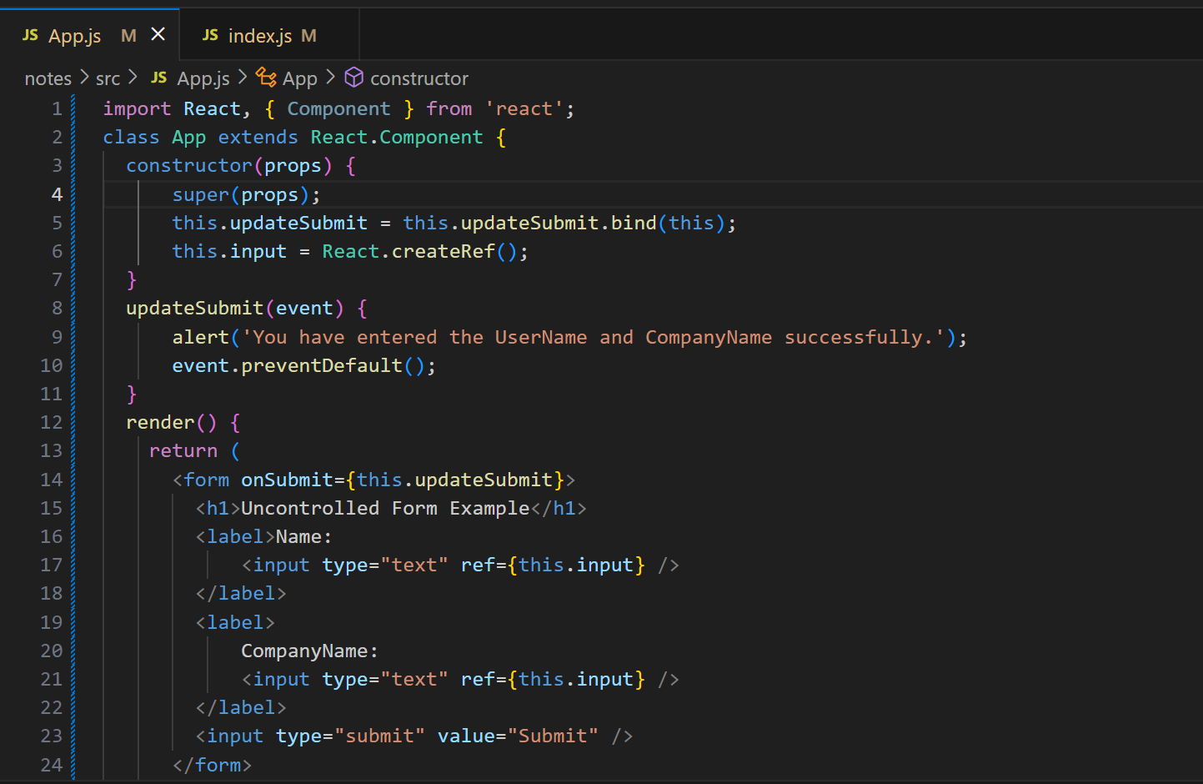

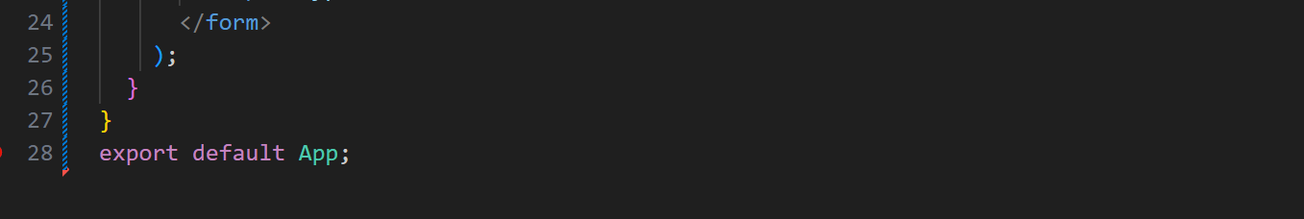

**Output:** 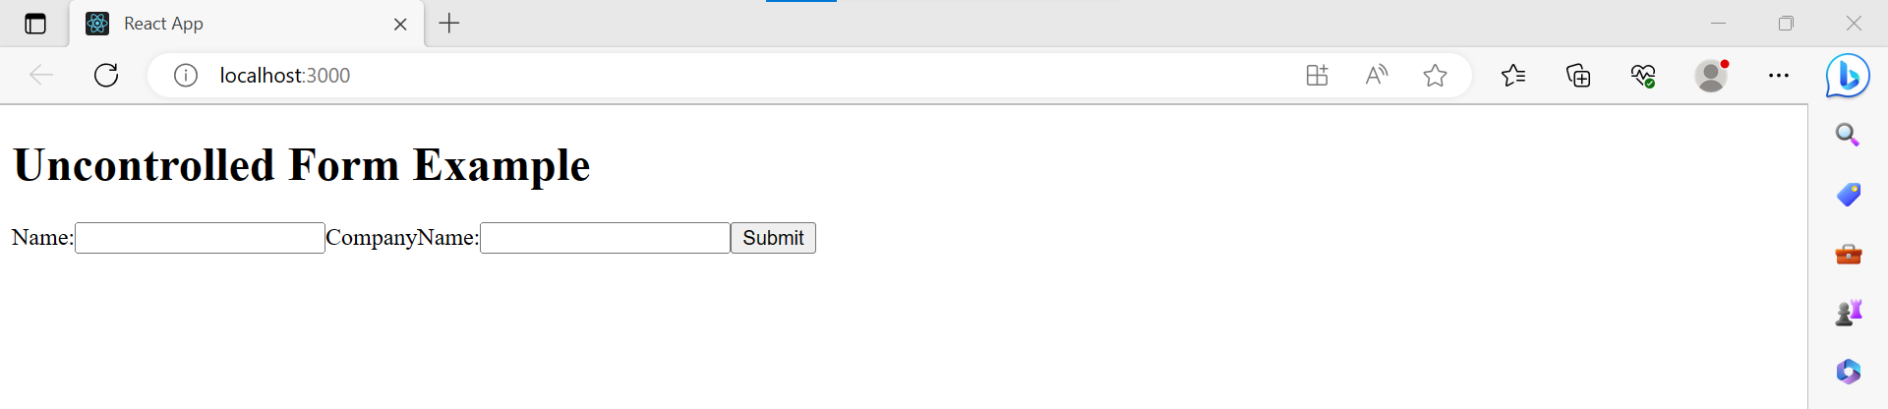

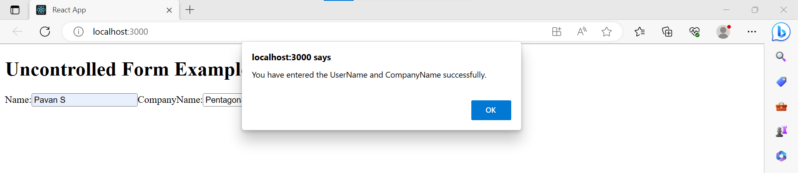

1. **Controlled Component:**

Controlled components have functions that govern the data passing into them on every **onChange event**, rather than grabbing the data only once.

**Example:**

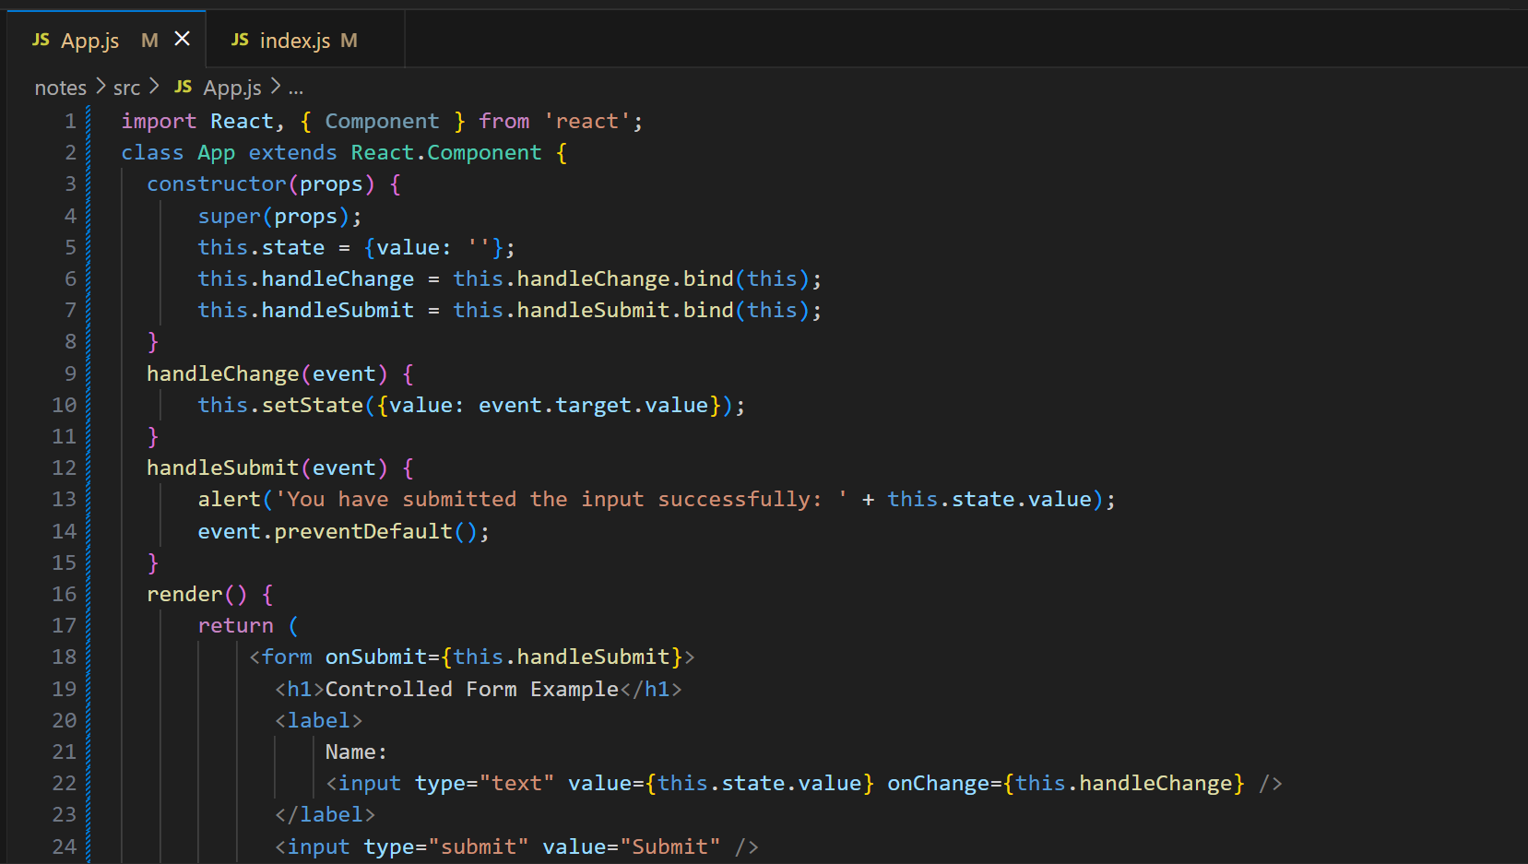

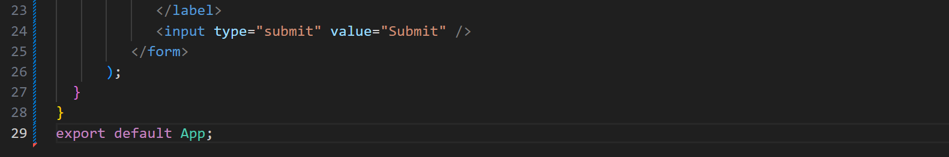

**Output:**

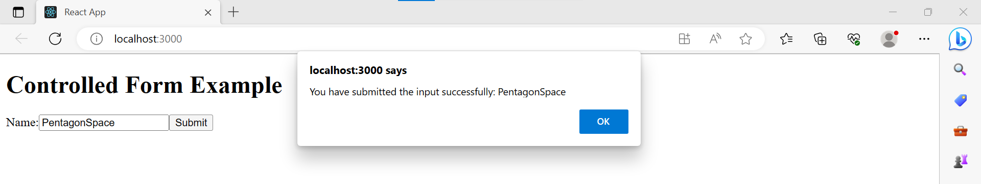

**Controlled Component Vs Uncontrolled Component:**

|  |  |
| --- | --- |
| **Controlled** | **Uncontrolled** |
| It does not maintain internal state. | It maintains internal states. |
| Data is controlled by the parent component. | Data is controlled by the DOM itself. |
| It accepts its current value as a prop. | It uses a ref for their current values. |
| It allows validation control. | It does not allow validation control. |
| It has better control over the form elements and data. | It has limited control over the form elements and data. |

**React Events:**

React has its own event handling system which is very similar to handling events on DOM elements. The react event handling system is known as Synthetic Events. The synthetic event is a cross-browser wrapper of the browser's native event.

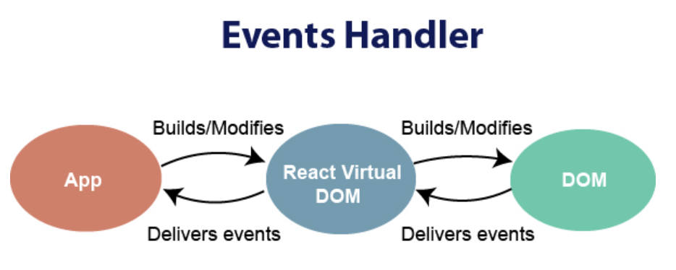

1. React events are named as camelCase instead of lowercase.
2. With JSX, a function is passed as the event handler instead of a string.

**Event declaration in plain HTML:**

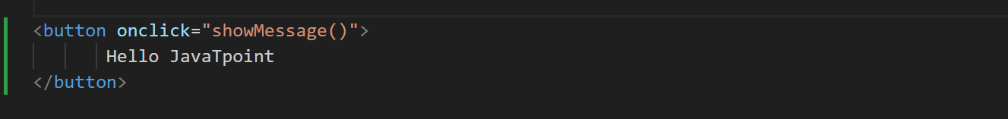

**Event declaration in React:**

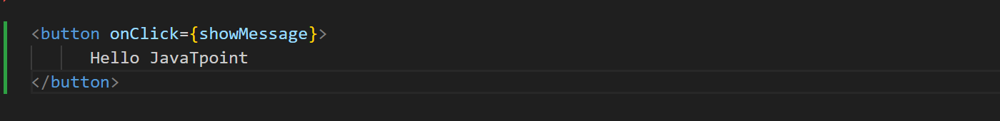

1. In react, we cannot return **false** to prevent the **default** behavior. We must call **prevent Default** event explicitly to prevent the default behavior.

**Example:**

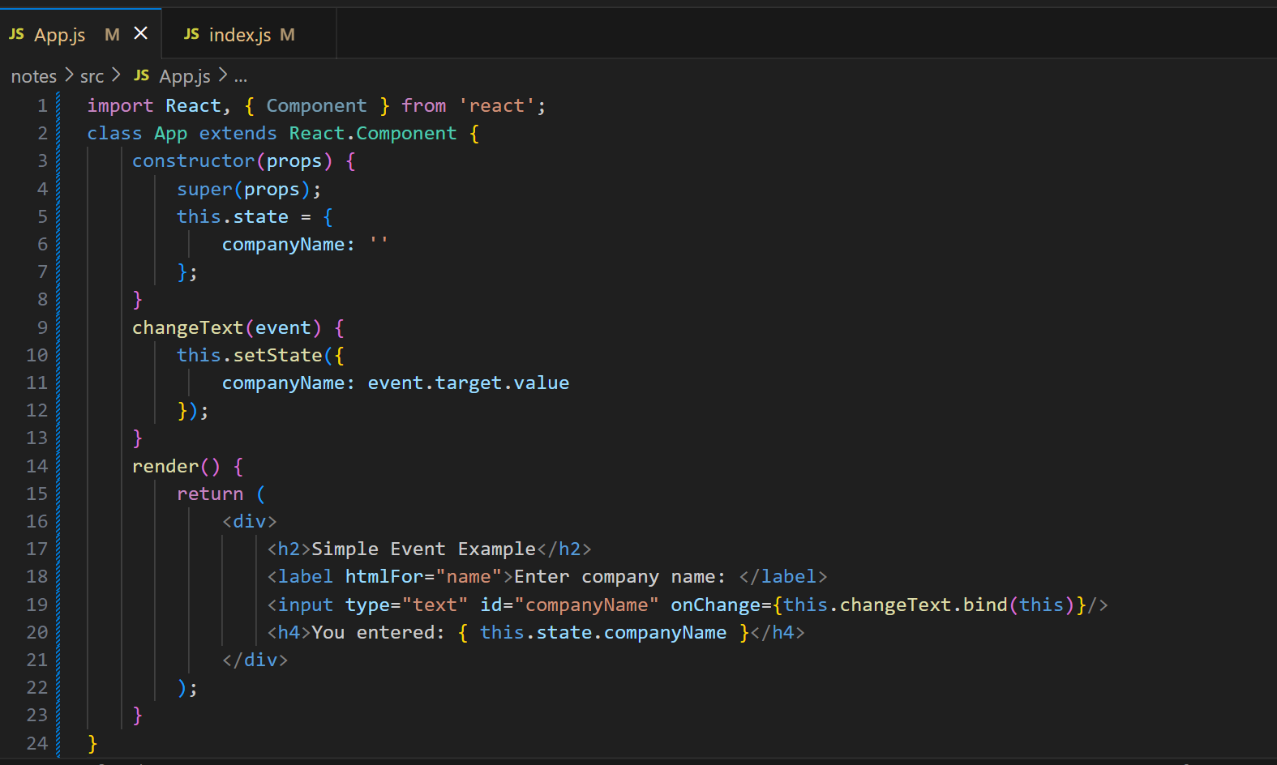

**Output:**

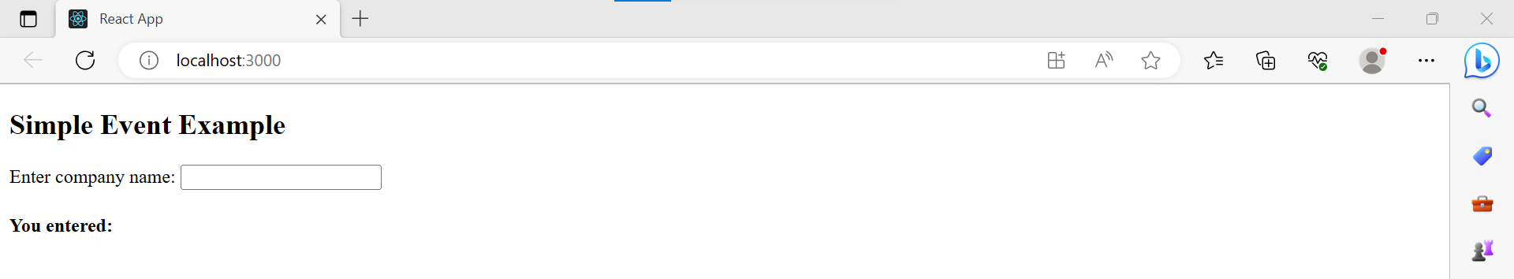

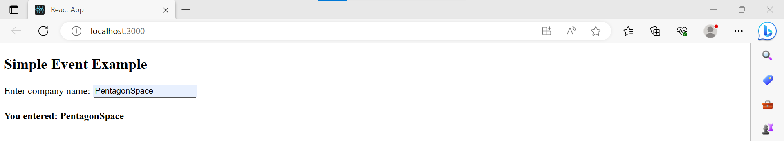

**React Conditional Rendering:**

There is more than one way to do conditional rendering in React.

* If
* Ternary operator
* Logical && operator
* Switch case operator
* Conditional Rendering with eums

**If:**

It is the easiest way to have a conditional rendering in React in the render method.

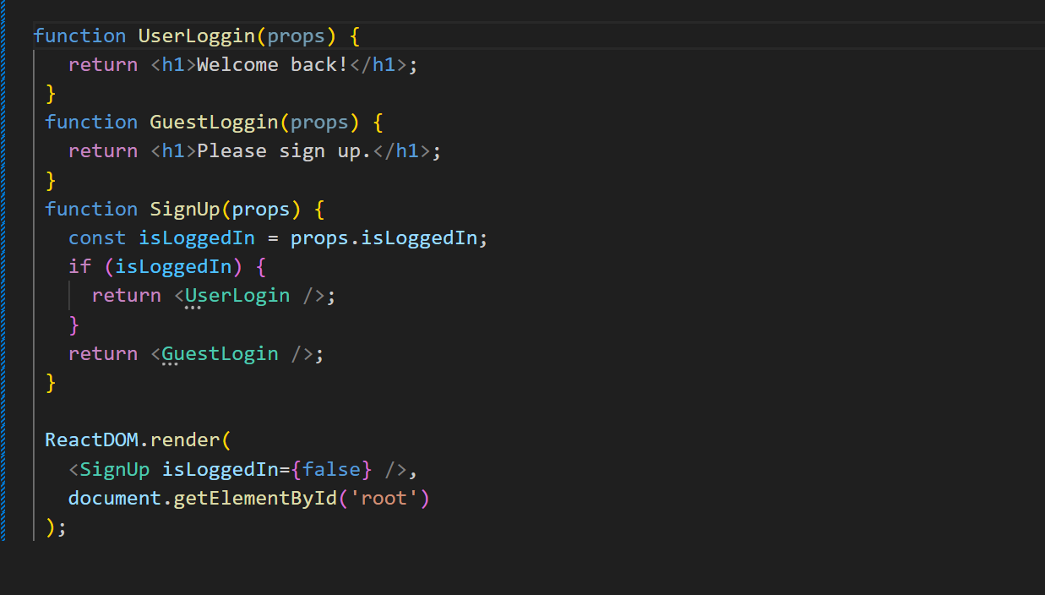

**Logical && operator:**

This operator is used for checking the condition.

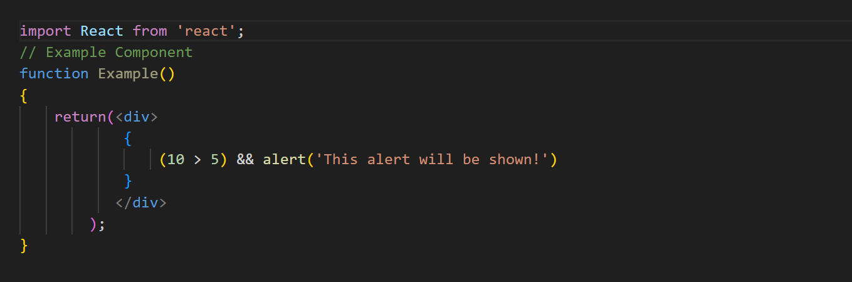

**Ternary operator:**

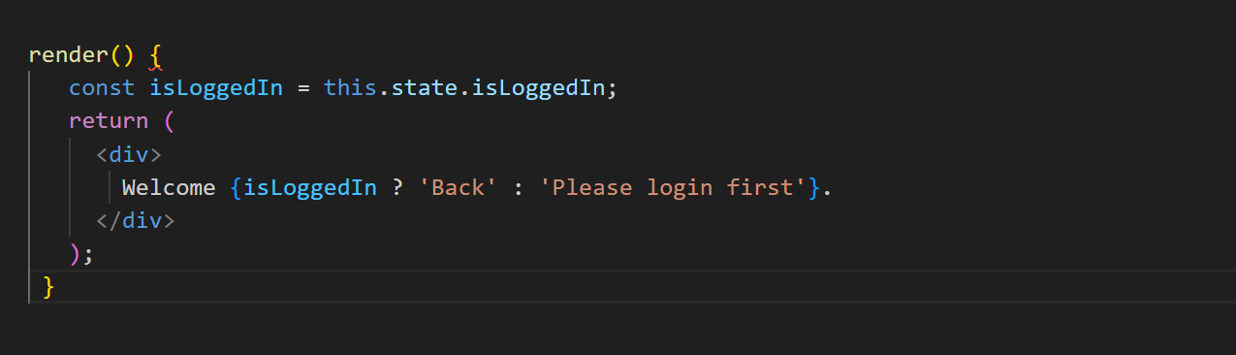

**Switch Case operator:**

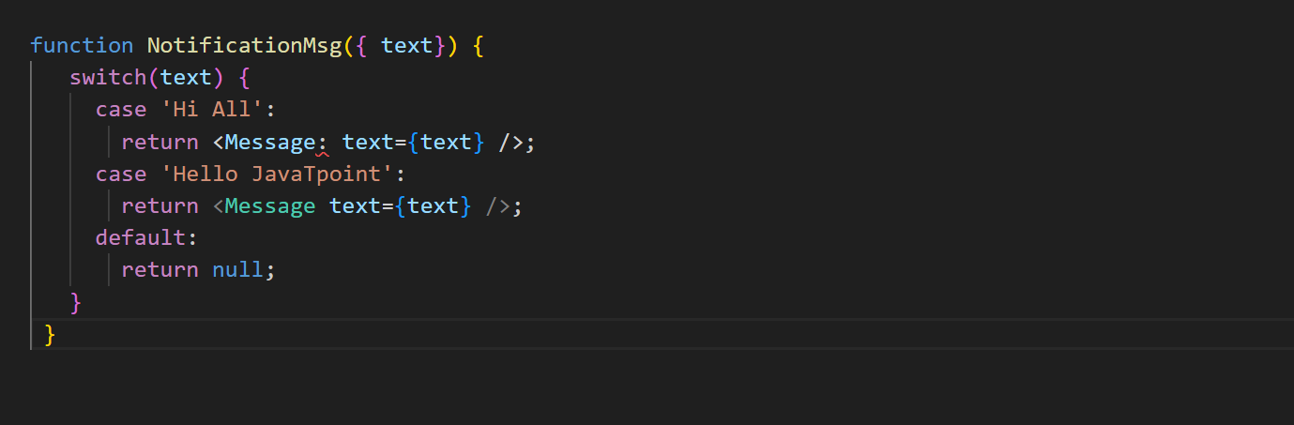

**Conditional Rendering with enums:**

An **enum** is a great way to have a multiple conditional rendering. It is more **readable** as compared to switch case operator.

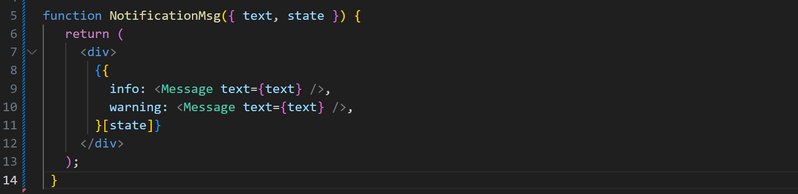

**React Lists:**

Lists are used to display data in an ordered format and mainly used to display menus on websites. The map() function is used for traversing the lists. Include this new list inside **<ul> </ul>** elements and render it to the DOM.

**Example:**

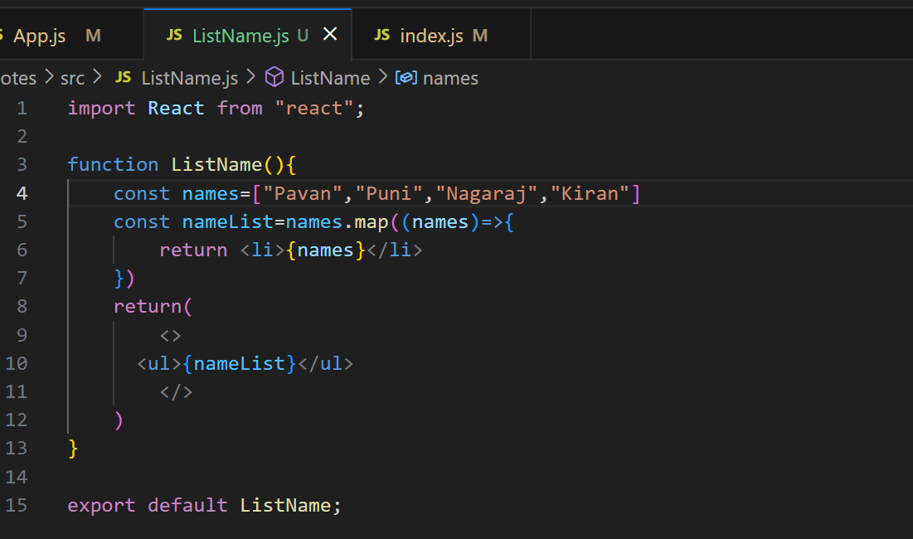

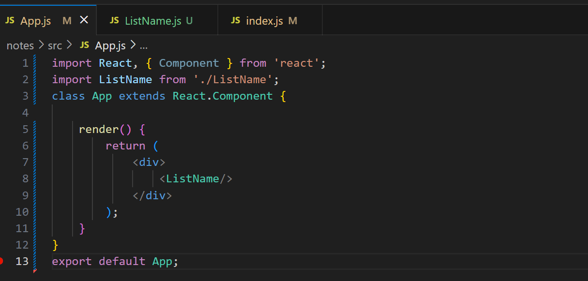

**Output:**

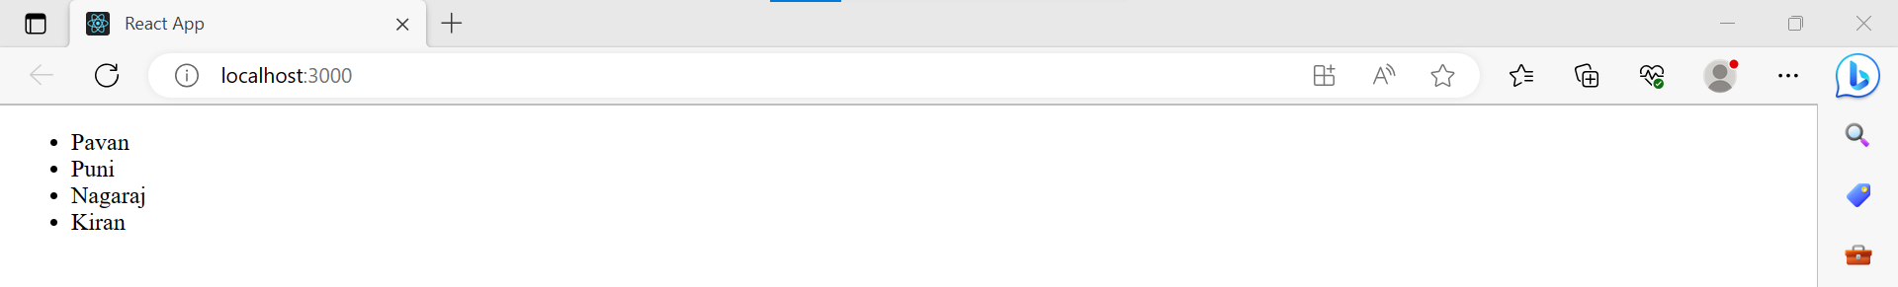

**React Keys:**

A key is a unique identifier. In React, it is used to identify which items have changed, updated, or deleted from the Lists. It is useful when we dynamically created components or when the users alter the lists. It also helps to determine which components in a collection needs to be re-rendered instead of re-rendering the entire set of components every time.

**Example:**

**ListName.js**

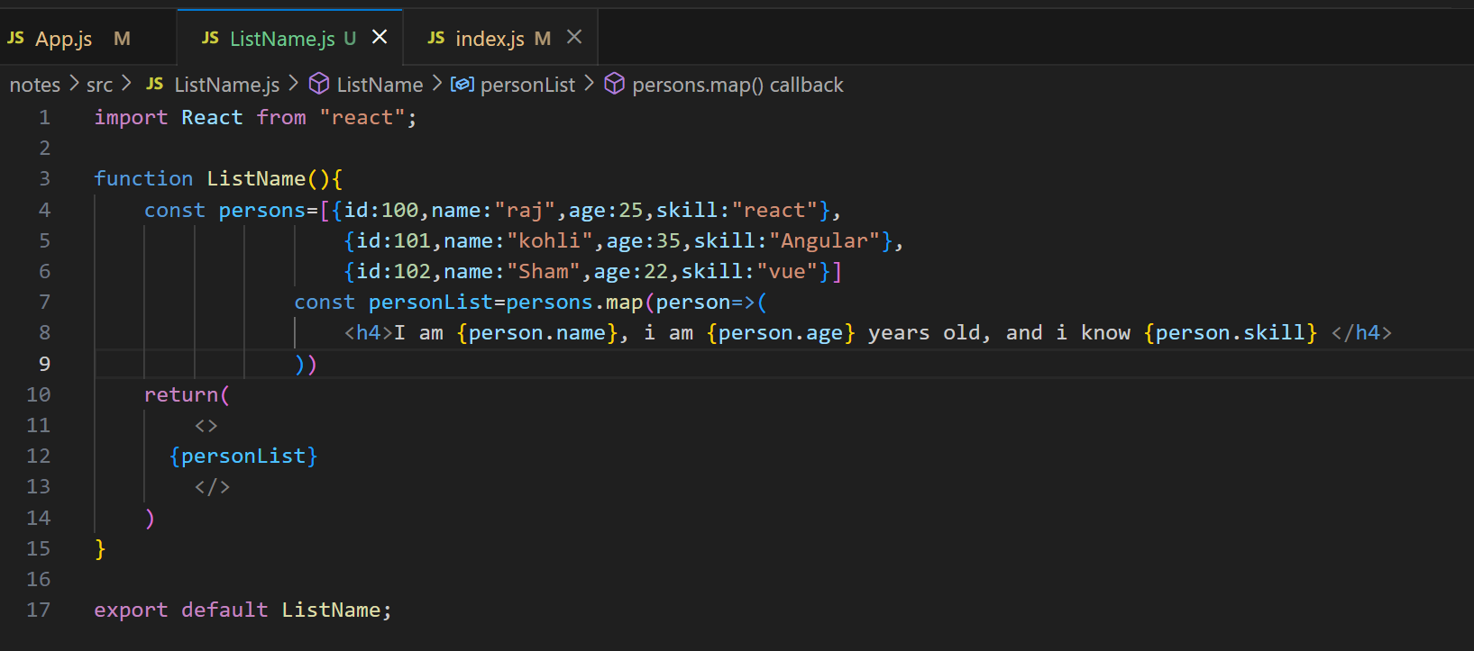

**App.js**



**Output:**

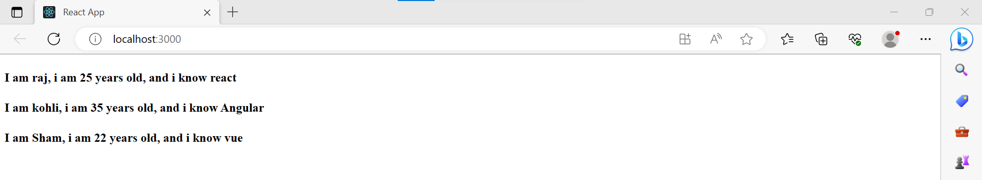

**React Refs:**

Refs is the shorthand used for **references** in React. It is similar to **keys** in React. It is an attribute which makes it possible to store a reference to particular DOM nodes or React elements. It provides a way to access React DOM nodes or React elements and how to interact with it.

**When to use Refs:**

* When we need DOM measurements such as managing focus, text selection, or media playback.
* It is used in triggering imperative animations.
* When integrating with third-party DOM libraries.
* It can also use as in call-backs.

**When to not use Refs:**

* Its use should be avoided for anything that can be done declaratively. For example, instead of using open() and close() methods on a Dialog component, you need to pass an isOpen prop to it.
* You should have to avoid overuse of the Refs.

**How to create Refs:**

In React, Refs can be created by using **React.createRef()**. It can be assigned to React elements via the **ref** attribute. It is commonly assigned to an instance property when a component is created, and then can be referenced throughout the component.

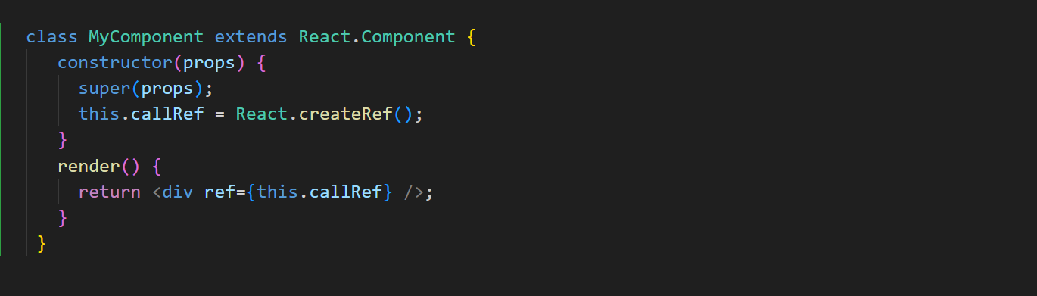

**How to access Refs:**

when a ref is passed to an element inside render method, a reference to the node can be accessed via the current attribute of the ref.

**const** node = **this**.callRef.current;

**Refs current Properties:**

* When the ref attribute is used in HTML element, the ref created with **React.createRef()** receives the underlying DOM element as its **current** property.
* When the ref attribute is used in HTML element, the ref created with **React.createRef()** receives the underlying DOM element as its **current** property.
* The ref attribute cannot be used on **function components** because they don't have instances.

**Callback refs:**

There is another way to use refs that is called "**callback refs**" and it gives more control when the refs are **set** and **unset**. Instead of creating refs by createRef() method, React allows a way to create refs by passing a callback function to the ref attribute of a component.

<input type="text" ref={element => **this**.callRefInput = element} />

The callback function is used to store a reference to the DOM node in an instance property and can be accessed elsewhere.

**this**.callRefInput.value

**React with useRef():**

It is introduced in **React 16.7** and above version. It helps to get access the DOM node or element, and then we can interact with that DOM node or element such as focussing the input element or accessing the input element value. It returns the ref object whose **.current** property initialized to the passed argument.

**Syntax:**

**const** refContainer = useRef(initialValue);

**Example:**

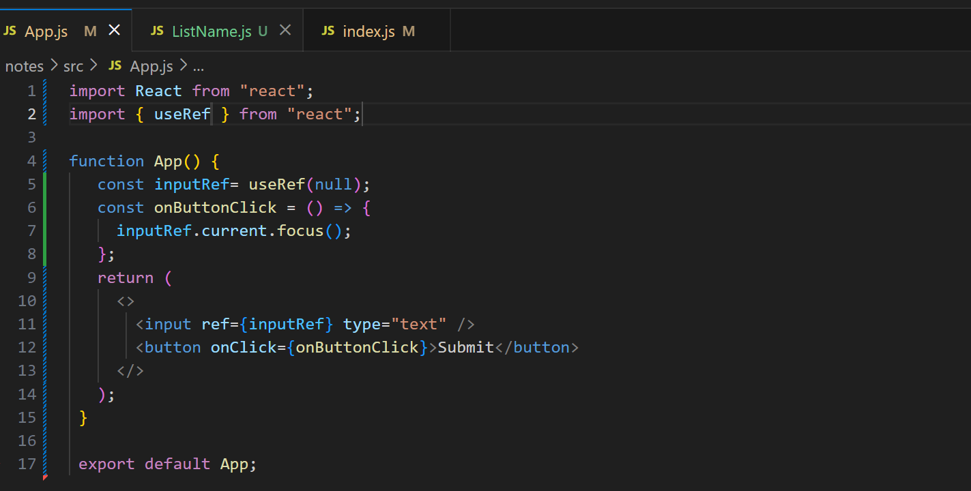

**React Fragments:**

The render method can return **single** elements or **multiple** elements. The render method will only render a single root node inside it at a time.

**Example:**

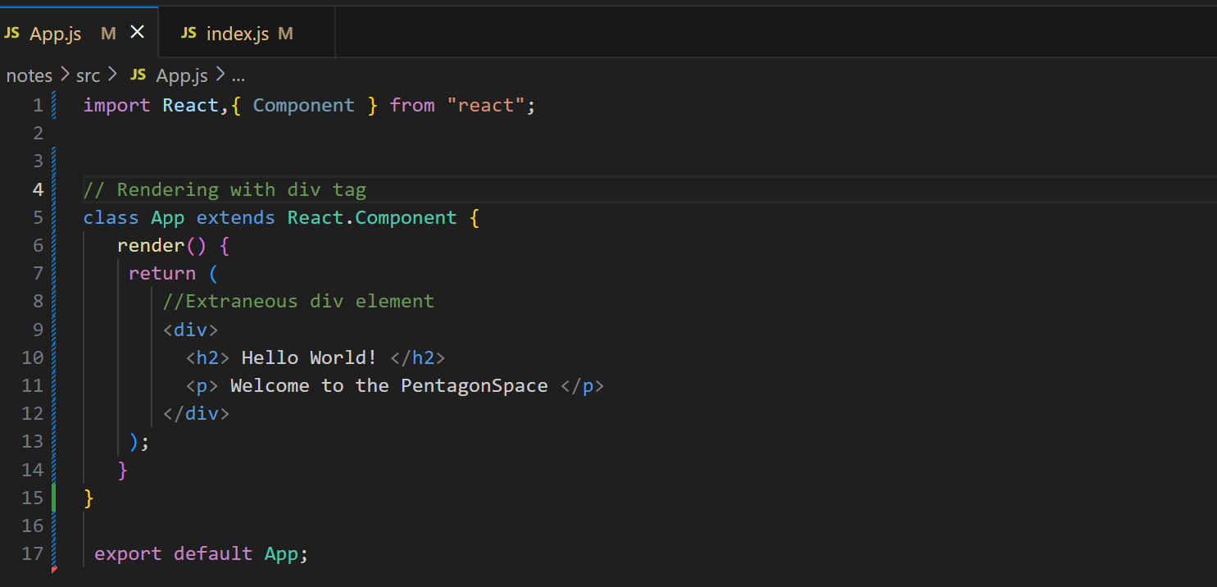

**Output:**

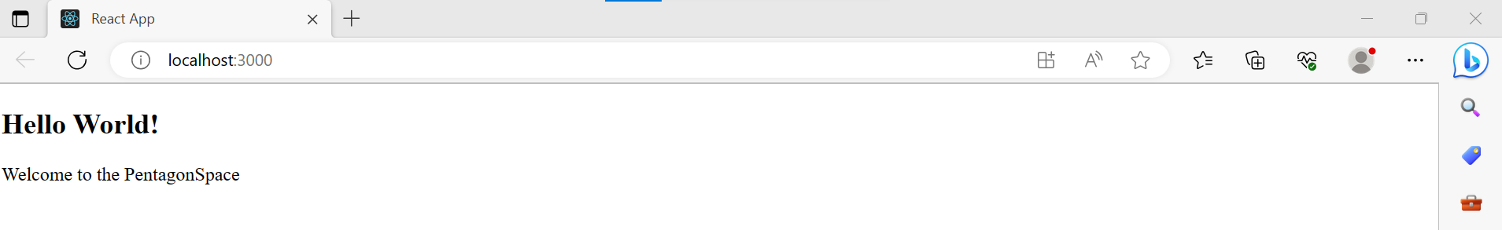

**Syntax:**

<React.Fragment>

<h2> child1 </h2>

<p> child2 </p>

.. ..... .... ...

</React.Fragment>

**Why we use Fragments:**

1. It makes the execution of code faster as compared to the div tag.
2. It takes less memory.

**Fragments Short Syntax:**

There is also another shorthand exists for declaring fragments for the above method. It looks like **empty** tag in which we can use of '<>' and '' instead of the '**React.Fragment**'.

**Example:**

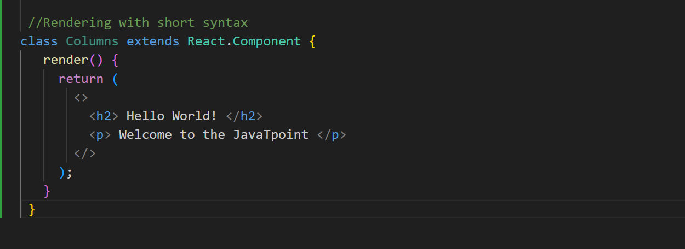

**Output:**

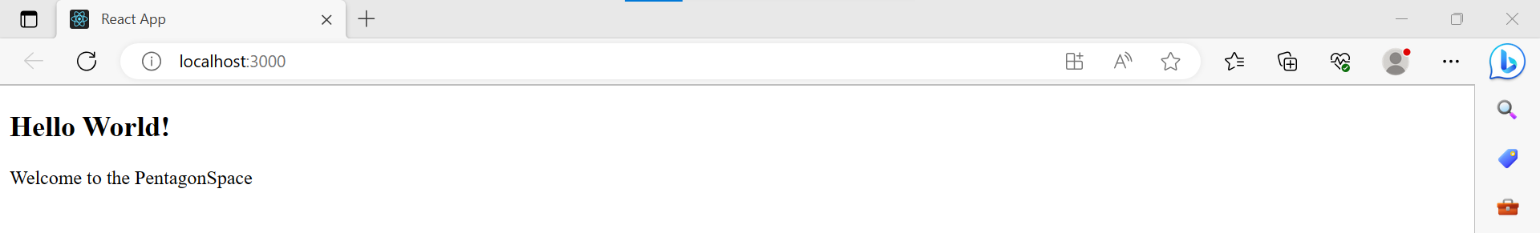

**Keyed Fragments:**

The shorthand syntax does not accept key attributes. You need a key for mapping a collection to an array of fragments such as to create a description list.

**Example:**

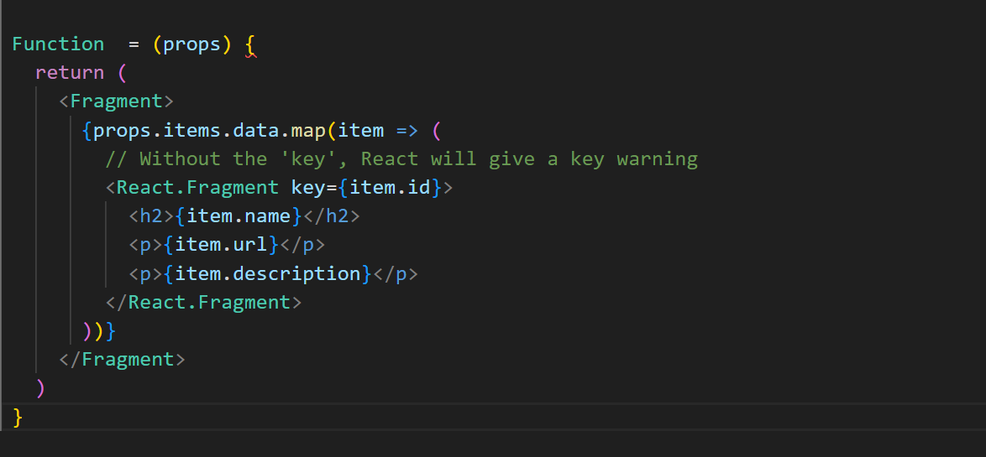

**React Router:**

Routing is a process in which a user is directed to different pages based on their action or request. ReactJS Router is mainly used for developing Single Page Web Applications. React Router is used to define multiple routes in the application.

React Router is a standard library system built on top of the React and used to create routing in the React application using React Router Package. It provides the synchronous URL on the browser with data that will be displayed on the web page.

React contains three different packages for routing. These are:

1. **react-router:** It provides the core routing components and functions for the React Router applications.
2. **react-router-native:** It is used for mobile applications.
3. **react-router-dom:** It is used for web applications design.

**$ npm install react-router-dom --save**

**Components in React Router:**

* **<Browser Router>:** It is used for handling the dynamic URL.
* **<Hash Router>:** It is used for handling the static request.

**Benefits of React Router:**

1. In this, it is not necessary to set the browser history manually.
2. Link uses to navigate the internal links in the application. It is similar to the anchor tag.
3. It uses Switch feature for rendering.
4. If The Router needs only a Single Child element.

**React CSS:**

CSS in React is used to style the React App or Component. The **style** attribute is the most used attribute for styling in React applications, which adds dynamically-computed styles at render time. It accepts a JavaScript object in **camelCased** properties rather than a CSS string.

1. **Inline Styling:**

The inline styles are specified with a JavaScript object in camelCase version of the style name. Its value is the style?s value, which we usually take in a string.

**Example:**

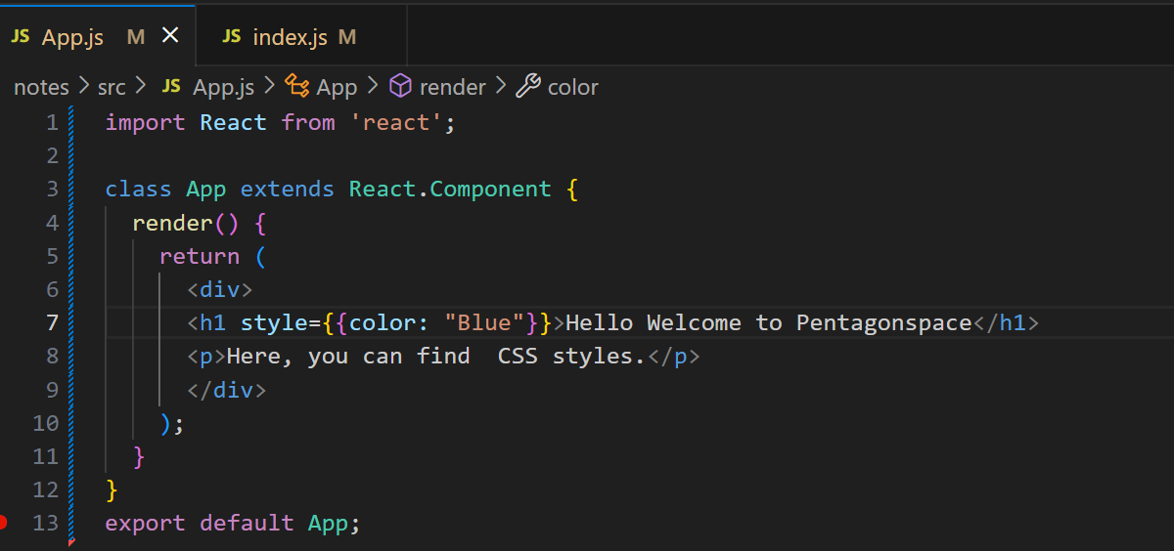

**Output:**

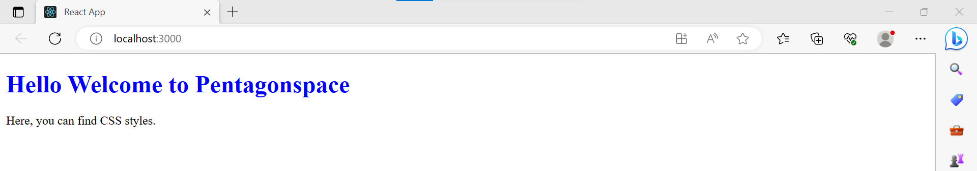

1. **CSS Stylesheet:**

You can write styling in a separate file for your React application, and save the file with a .css extension. Now, you can **import** this file in your application.

**Example:**

**App.js**

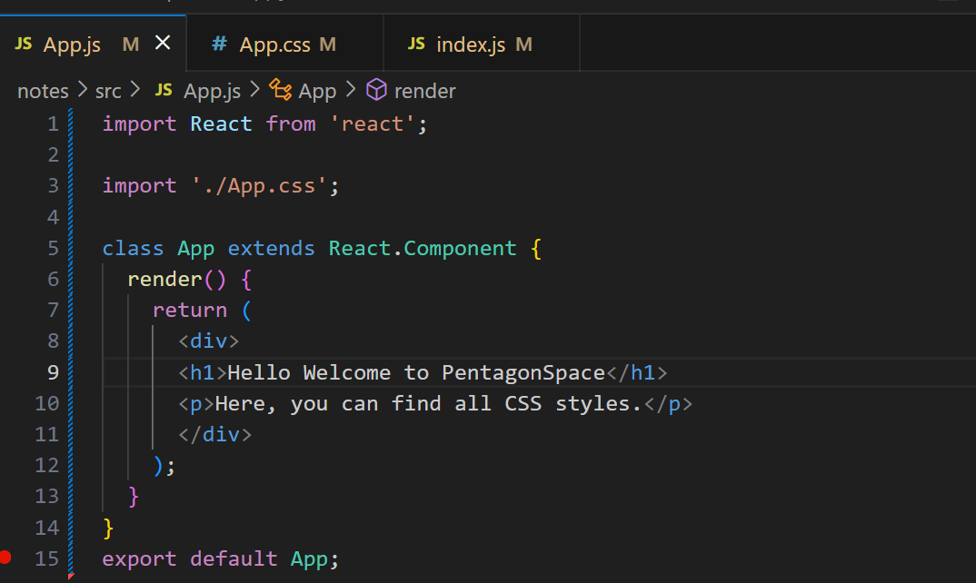

**App.css**

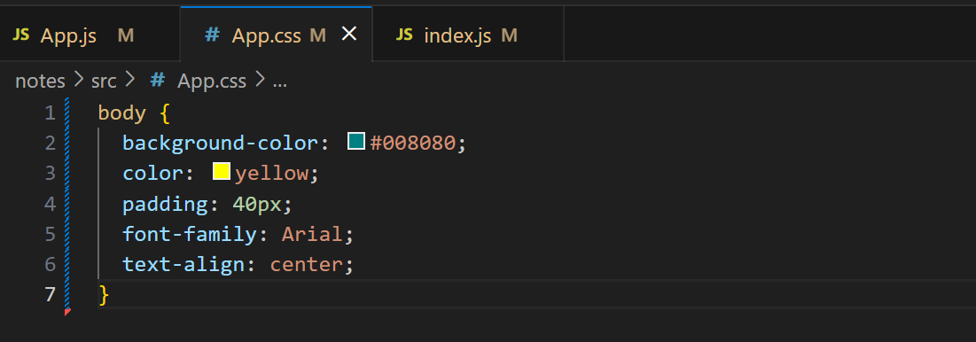

**Output:**

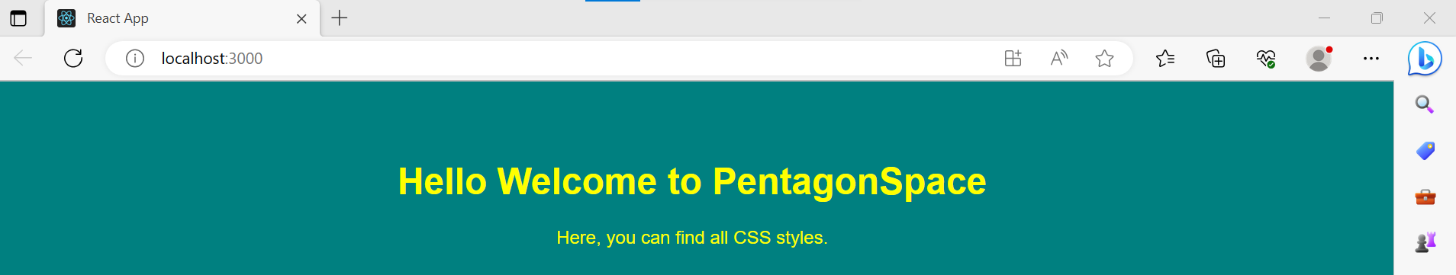

1. **CSS module:**

CSS Module is another way of adding styles to your application. It is a **CSS file** where all class names and **animation** names are scoped locally by default. It is available only for the component which imports it, means any styling you add can never be applied to other components without your permission, and you never need to worry about name conflicts.

**Example:**

**App.js**

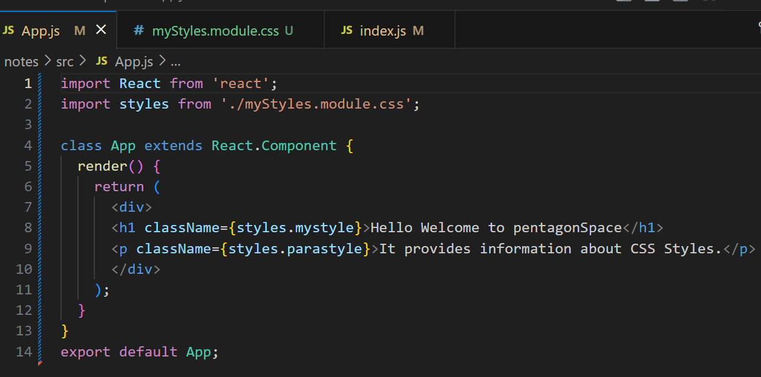

**myStyles.module.css**

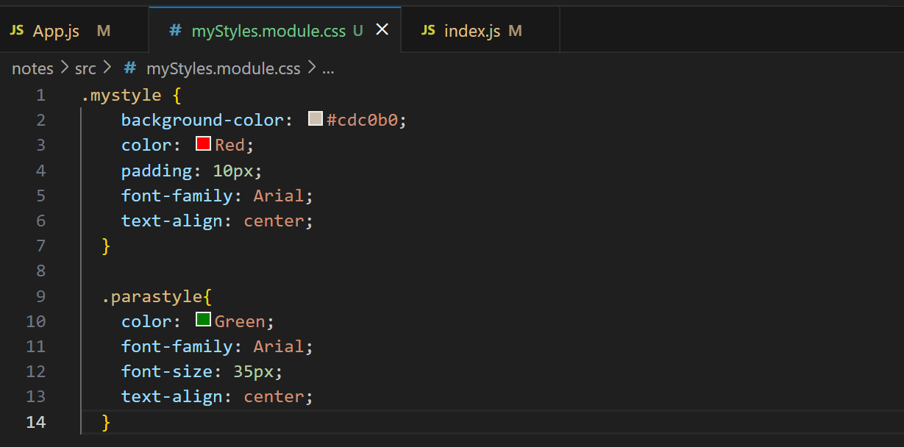

**Output:**

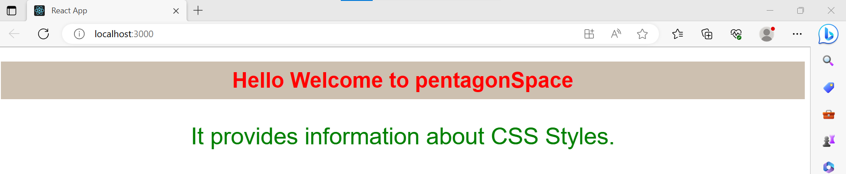

1. **Styled Component:**

Styled-components is a **library** for React. It uses enhance CSS for styling React component systems in your application, which is written with a mixture of JavaScript and CSS.

**The styled-components provides:**

* Automatic critical CSS
* No class name bugs
* Easier deletion of CSS
* Simple dynamic styling
* Painless maintenance

**React Animation:**

The animation is a technique in which images are manipulated to appear as moving images. It is one of the most used technique to make an interactive web application.

React Transition group has mainly **two APIs** to create transitions.

1. **ReactTransitionGroup:** It uses as a low-level API for animation.
2. **ReactCSSTransitionGroup:** It uses as a high-level API for implementing basic CSS transitions and animations.

**React Transition Group Components**

 Provides **three** main components.

1. Transition
2. CSS Transition
3. Transition Group

**Transition:**

It has a simple component API to describe a transition from one component state to another over time. It is mainly used to animate the **mounting** and **unmounting** of a component. It can also be used for in-place transition states as well.

* Entering
* Entered
* Exiting
* Exited

**CSS Transition:**

The CSS Transition component uses CSS stylesheet classes to write the transition and create animations. It is inspired by the **ng-animate** library. It can also inherit all the props of the transition component.

* Appear
* Enter
* Exit

**Transition Group:**

This component is used to manage a set of transition components (Transition and CSSTransition) in a list. It is a state machine that controls the **mounting** and **unmounting** of components over time. The Transition component does not define any animation directly. Here, how 'list' item animates is based on the individual transition component. It means, the "TransitionGroup" component can have different animation within a component.

**React Map:**

A map is a data collection type where data is stored in the form of pairs. It contains a unique key. The value stored in the map must be mapped to the key. We cannot store a duplicate pair in the map(). It is because of the uniqueness of each stored key. It is mainly used for fast searching and looking up data.

**React Table:**

A table is an arrangement which organizes information into rows and columns. It is used to store and display data in a structured format.

The react-table is a lightweight, fast, fully customizable (JSX, templates, state, styles, callbacks), and extendable Datagrid built for React. It is fully controllable via optional props and callbacks.

**Features:**

1. It is lightweight at 11kb (and only need 2kb more for styles).
2. It is fully customizable (JSX, templates, state, styles, callbacks).
3. It is fully controllable via optional props and callbacks.
4. It has client-side & Server-side pagination.
5. It has filters.
6. Pivoting & Aggregation
7. Minimal design & easily themeable

**Example:**

**App.js**

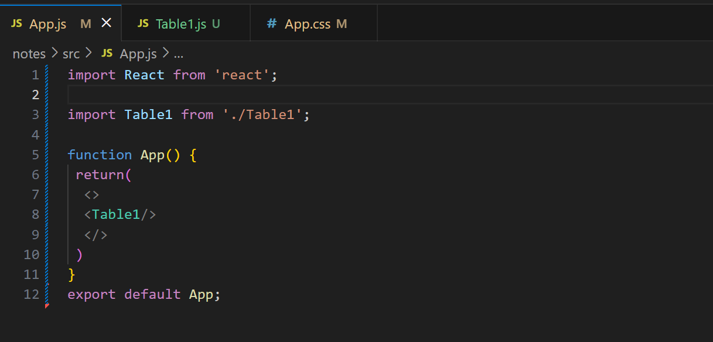

**Table1.js**

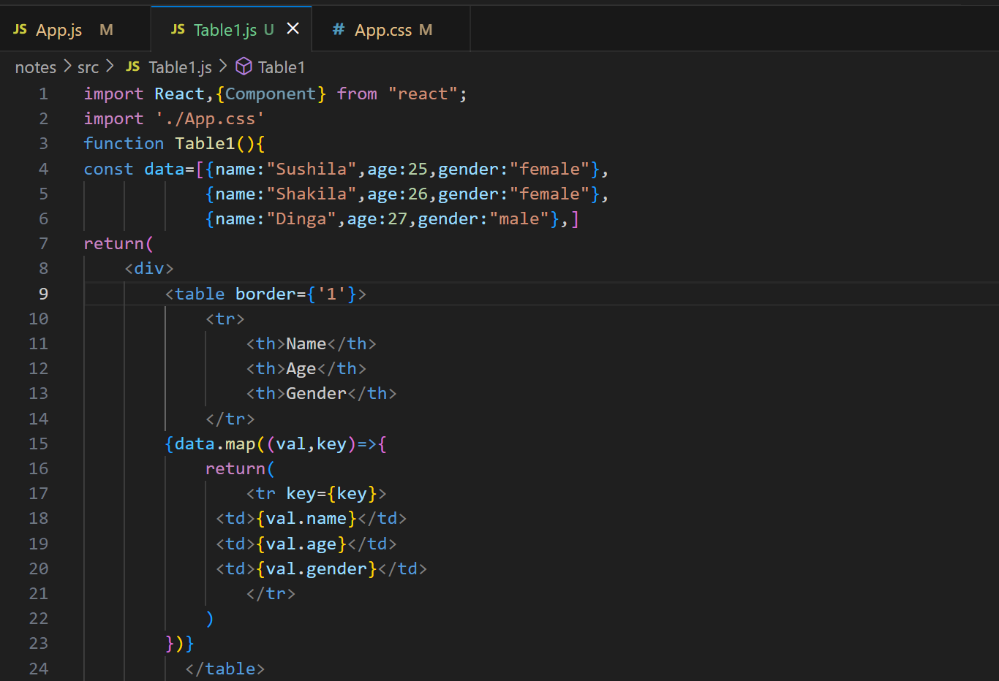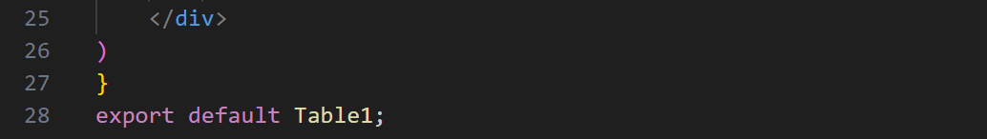

**App.css**

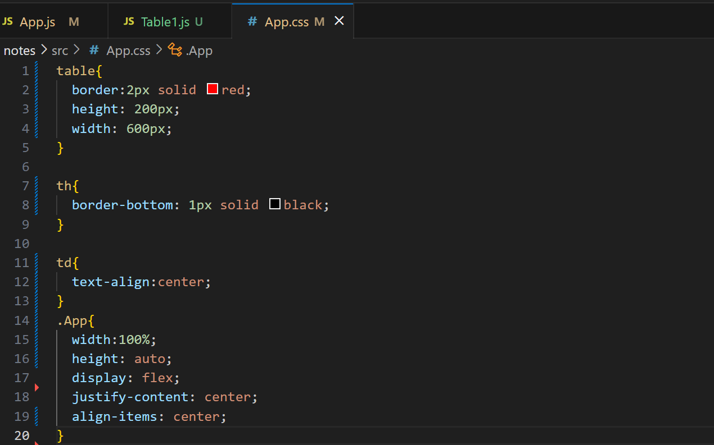

**Output:**

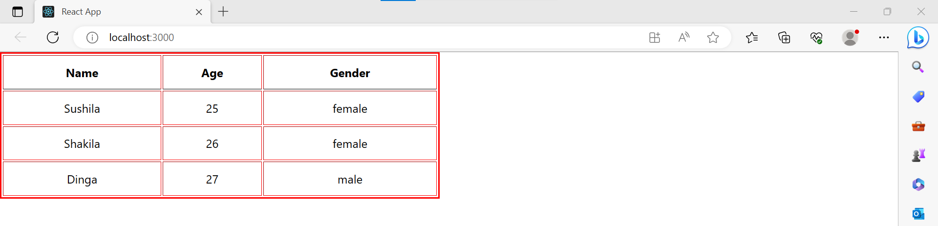

**React Higher-Order Component:**

It is also known as HOC. In React, HOC is an advanced technique for reusing component logic. It is a function that takes a component and returns a new component.

**Syntax:**

**const NewComponent = higherOrderComponent(WrappedComponent);**

**Example:**

**HOC.js**

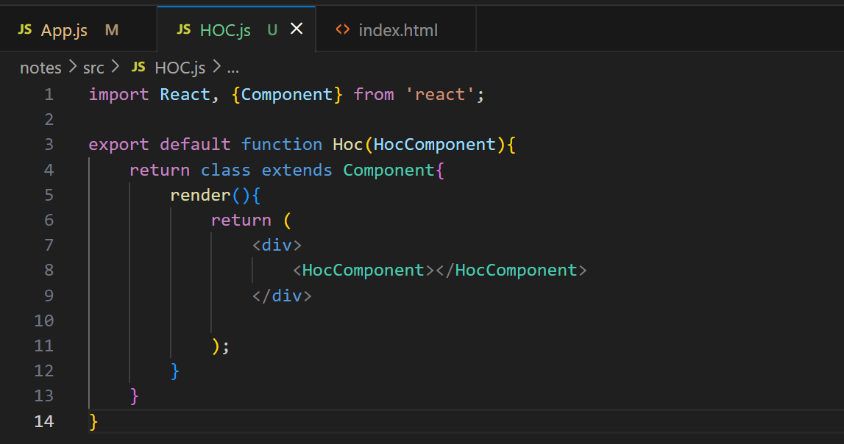

**App.js**

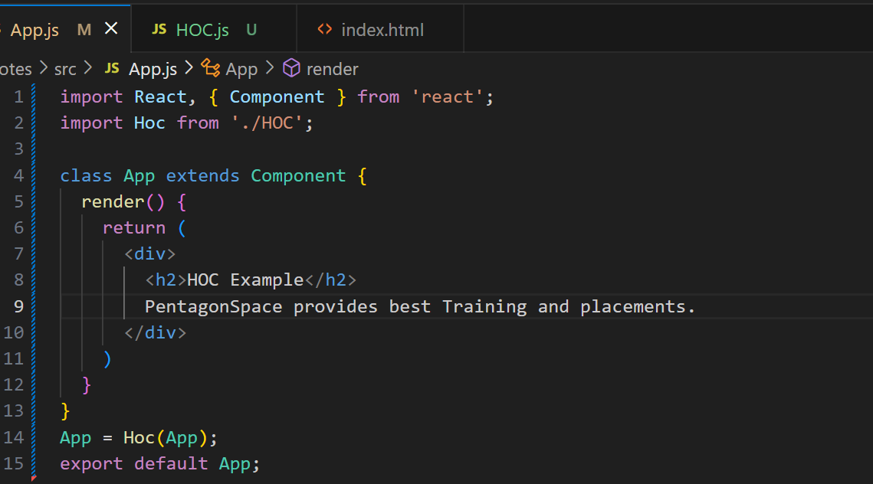

**Output:**

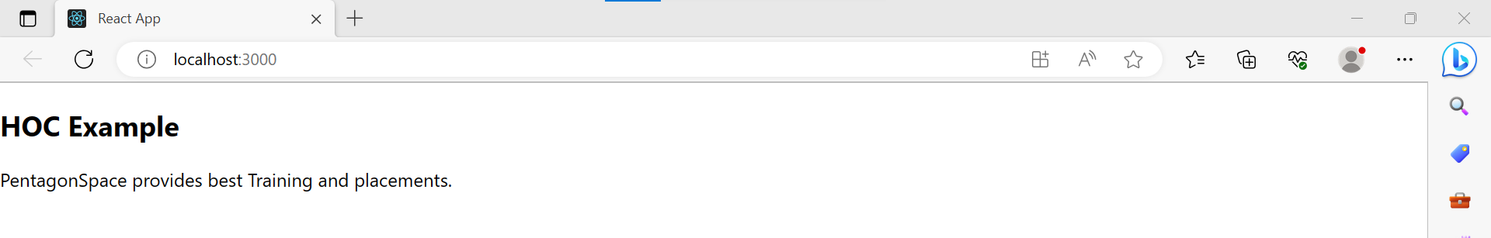

**React Code Splitting:**

The React app bundled their files using tools like **Webpack** or **Browserfy**. Bundling is a process which takes multiple files and merges them into a single file, which is called a **bundle**. The bundle is responsible for loading an entire app at once on the webpage.

**The code splitting improves:**

* The performance of the app
* The impact on memory
* The downloaded Kilobytes (or Megabytes) size

**React Lazy:**

The best way for code splitting into the app is through the dynamic **import()** syntax. The React.lazy function allows us to render a dynamic import as a regular component.

**Before:**

**import** ExampleComponent from './ExampleComponent';

function MyComponent() {

**return** (

<div>

<ExampleComponent />

</div>

);

}

**After:**

**const** ExampleComponent = React.lazy(() => **import**('./ExampleComponent'));

function MyComponent() {

**return** (

     <div>

       <ExampleComponent />

     </div>

   );

}

**Error Boundaries:**

If any module fails to load, for example, due to network failure, we will get an error. We can handle these errors with Error Boundaries. Once we have created the Error Boundary, we can use it anywhere.

**Example:**

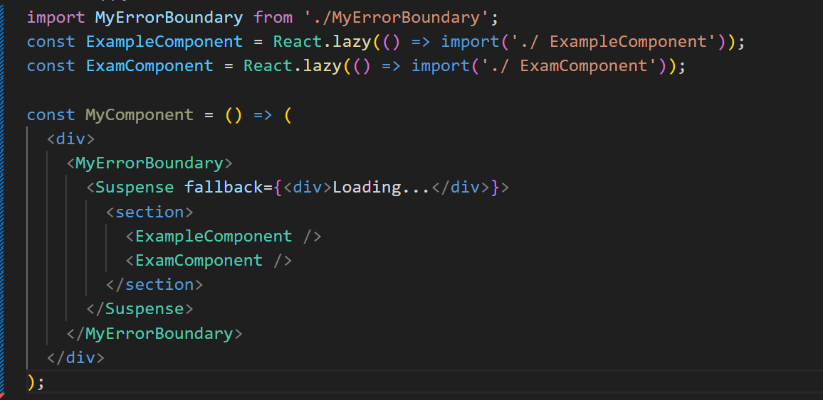

**React Context:**

Context allows passing data through the component tree without passing props down manually at every level.

**React Context API:**

1. React.createContext
2. Context.provider
3. Context.Consumer
4. Class.contextType

* **React.createContext:**

It creates a context object.

**const MyContext = React.createContext(defaultValue);**

* **Context.Provider:**

Every Context object has a Provider React component which allows consuming components to subscribe to context changes.

**<MyContext.Provider value={/* some value */}>**

* **Context.Consumer:**

It is the React component which subscribes to the context changes. It allows us to subscribe to the context within the function component

**<MyContext.Consumer>**

**{value => /* render something which is based on the context value */}**

**</MyContext.Consumer>**

* **Class context Type:**

The contextType property on a class used to assign a Context object which is created by React.createContext(). It allows you to consume the closest current value of that Context type using this.context.

**Example:**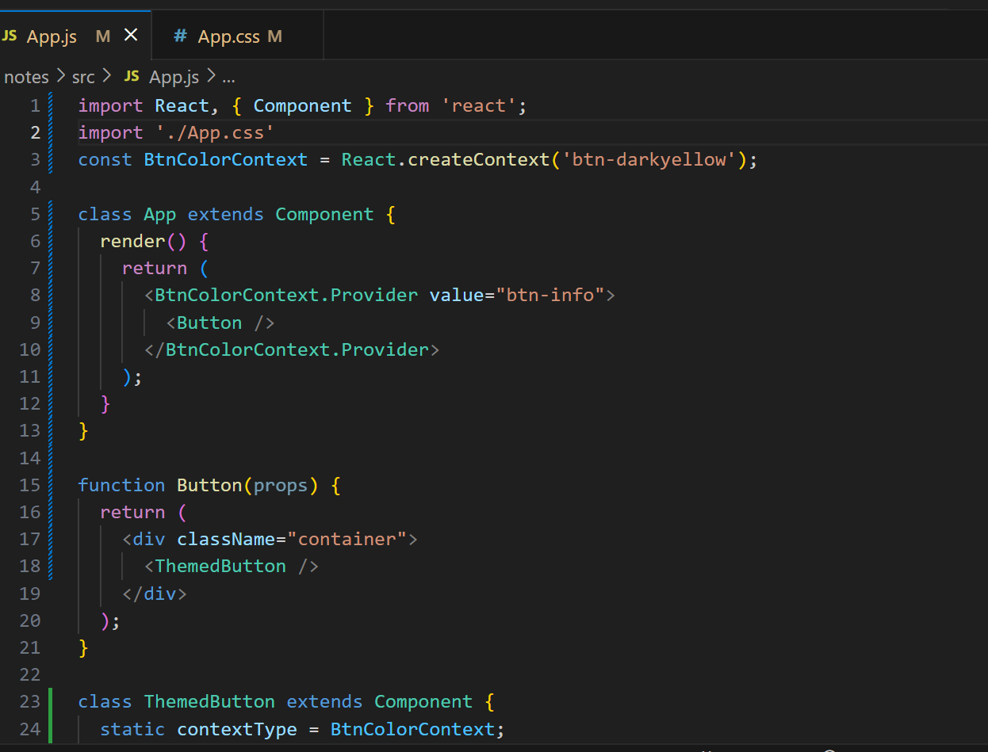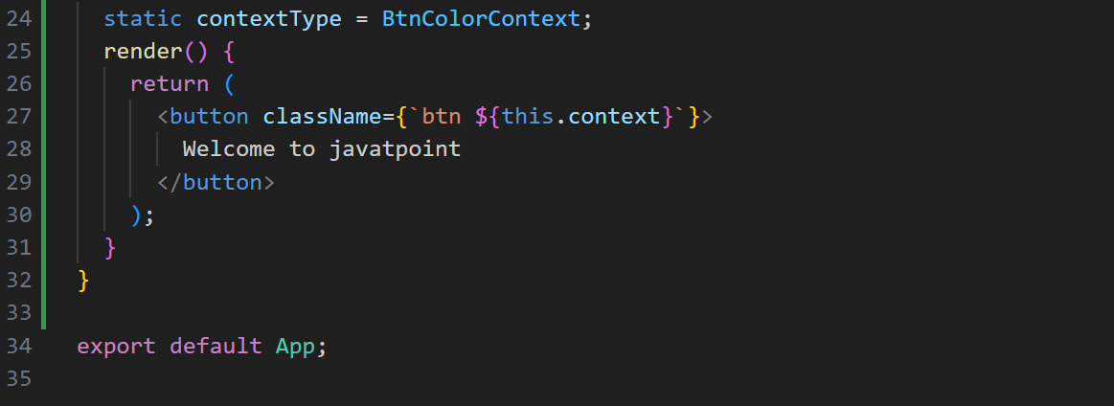

**Output:**

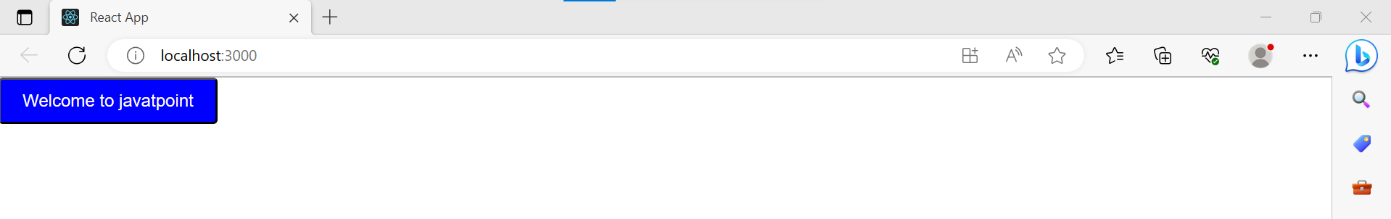

**React Hooks:**

Hooks are the new feature introduced in the React 16.8 version. It allows you to use state and other React features without writing a class.

**Rules of Hooks:**

1. Only call Hooks at the top level
2. Only call Hooks from React functions

**Hooks State:**

Hook state is the new way of declaring a state in React app. Hook uses useState() functional component for setting and retrieving state.

**Example:**

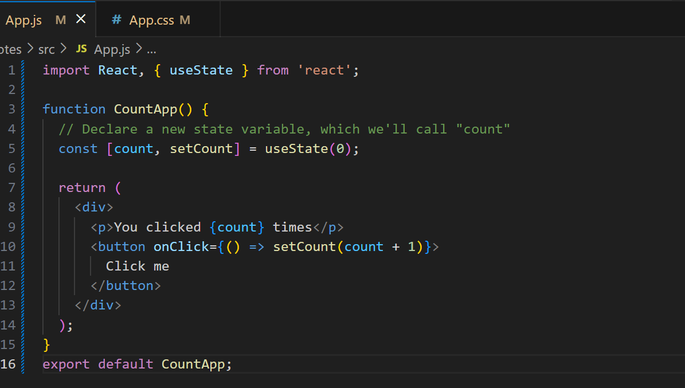

**Output:**

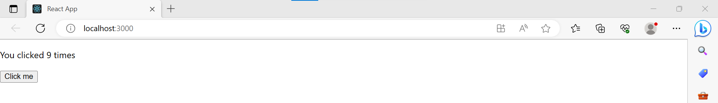

**React Flux Vs MVC:**

**MVC**

MVC stands for Model View Controller. It is an architectural pattern used for developing the user interface.

**MVC Architecture:**

* **Model:** It is responsible for maintaining the behaviour and data of an application.
* **View:**  It is used to display the model in the user interface.
* **Controller:** It acts as an interface between the Model and the View components. It takes user input, manipulates the data(model) and causes the view to update.

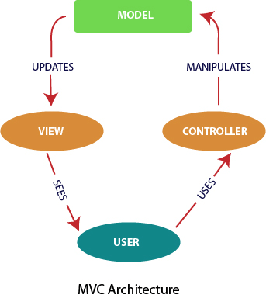

**FLUX:**

 Flux is the application architecture that Facebook uses for building client-side web applications.

Flux Architecture has three major roles in dealing with data:

1. **Dispatcher**
2. **Store**
3. **Views**

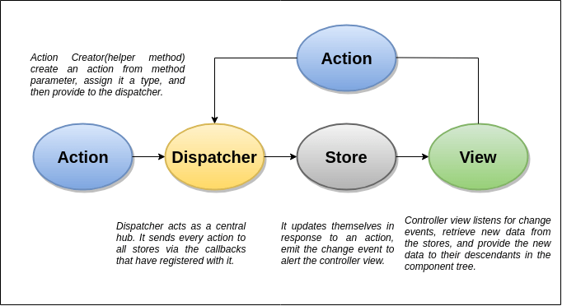

|  |  |
| --- | --- |
| **MVC** | **FLUX** |
| It was introduced in 1976. | It was introduced just a few years ago. |
| It supports Bi-directional data Flow model. | It supports Uni-directional data flow model. |
| In this, data binding is the key. | In this, events or actions are the keys. |
| It is synchronous. | It is asynchronous. |
| Here, controllers handle everything(logic). | Here, stores handle all logic. |
| It is hard to debug. | It is easy to debug because it has common initiating point: Dispatcher. |
| It is difficult to understand as the project size increases. | It is easy to understand. |
| Its maintainability is difficult as the project scope goes huge. | Its maintainability is easy and reduces runtime errors. |
| Testing of application is difficult. | Testing of application is easy. |
| Scalability is complex. | It can be easily scalable. |

**React Redux:**

Redux was inspired by Flux. Redux studied the Flux architecture.

* Redux does not have Dispatcher concept.
* Redux has an only Store whereas Flux has many Stores.
* The Action objects will be received and handled directly by Store.

**React Architecture:**

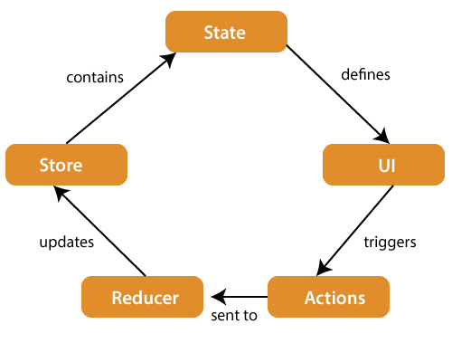

**Store:**  A Store is a place where the entire state of your application lists. It manages the status of the application and has a dispatch(action) function. It is like a brain responsible for all moving parts in Redux.

**Action:** Action is sent or dispatched from the view which are payloads that can be read by Reducers. It is a pure object created to store the information of the user's event. It includes information such as type of action, time of occurrence, location of occurrence, its coordinates, and which state it aims to change.

**Reducer:** Reducer read the payloads from the actions and then updates the store via the state accordingly. It is a pure function to return a new state from the initial state.

**React Portals:**

 It is very tricky to render the child component outside of its parent component hierarchy. If we do this, it breaks the convention where a component needs to render as a new element and follow a **parent-child** hierarchy. In React, the parent component always wants to go where its child component goes. That's why React portal concept comes in.

**Syntax:**

**ReactDOM.createPortal(child, container)**

**Features:**

* It uses React version 16 and its official API for creating portals.
* It has a fallback for React version 15.
* It transports its children component into a new React portal which is appended by default to document.body.
* It can also target user specified DOM element.
* It supports server-side rendering
* It supports returning arrays (no wrapper div's needed)
* It uses <Portal /> and <PortalWithState /> so there is no compromise between flexibility and convenience.
* It doesn't produce any DOM mess.
* It has no dependencies, minimalistic.

**When to use?**

1. Modals
2. Tool tips
3. Floating menus
4. Widgets

**Example:**

**App.js**

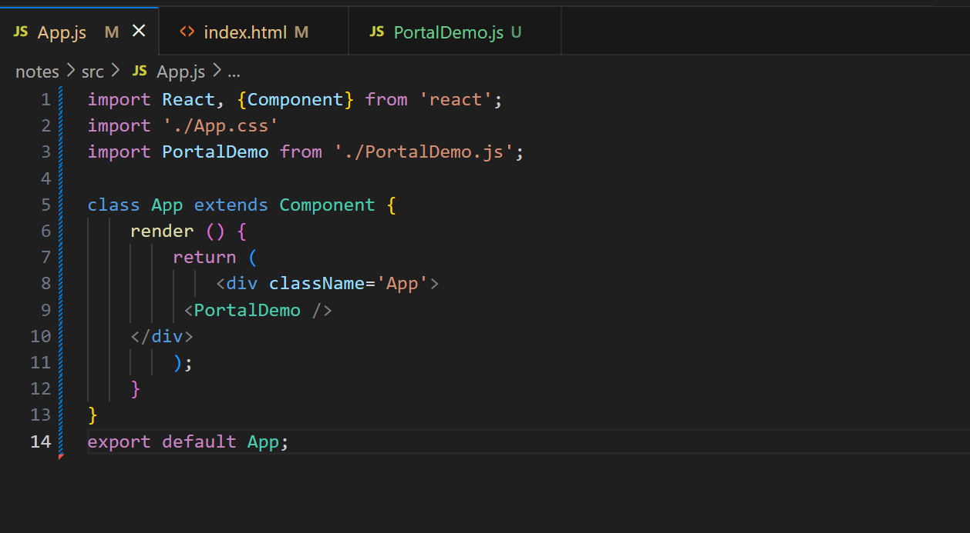

**PortalDemo.js**

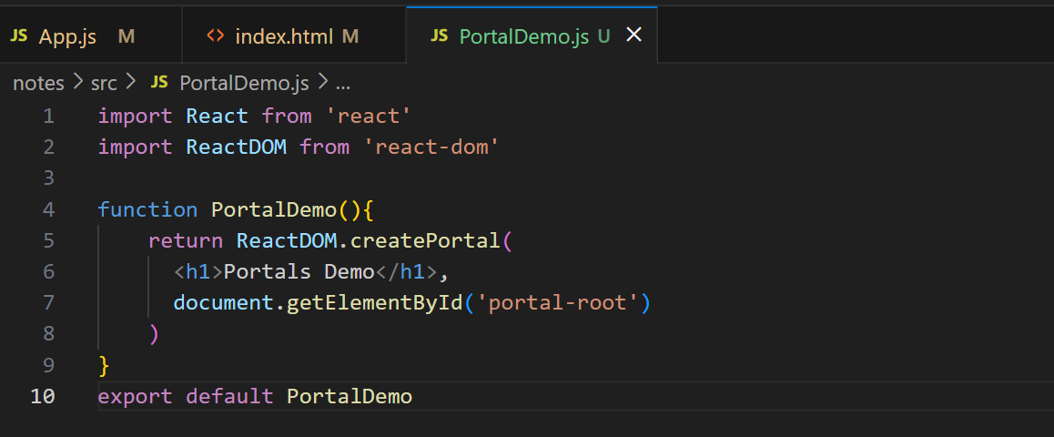

**Index.HTML**

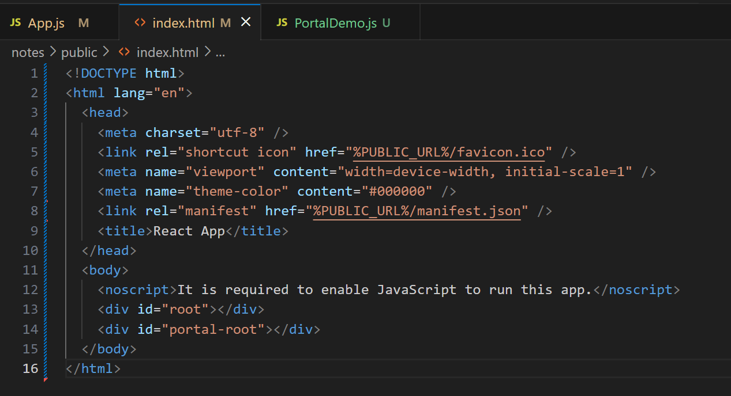**Output:**

